**FUEL CELL BASED ULTRA VOLTAGE GAIN BOOST CONVERTER FOR EV APPLICATIONS**

# A Project Report

Submitted in partial fulfillment of the requirements for the award of the Degree of

# BACHELOR OF TECHNOLOGY IN ELECTRICAL AND ELECTRONICS ENGINEERING

*by*

## G. VINAY KUMAR (20P65A0222) B. JHANSI (19P61A0218) B. VINAY KUMAR (19P61A0217) B. SANDEEP (20P65A0205)

Under the esteemed guidance of

**Dr. B. NAGI REDDY M. Tech.Ph. D, MISRD**

# Associate Professor

## DEPARTMENT OF ELECTRICAL & ELCTRONICS ENGINEERING



# VIGNANA BHARATHI INSTITUTE OF TECHNOLOGY

**(An Autonomous Institution, Accredited by NBA and NAAC, New Delhi) Aushapur (V), Ghatkesar (M), Medchal Dist, Telangana-501301**

# 2019-23



**Aushapur (V), Ghatkesar (M), Medchal Dist, Telangana -501301**

**DEPARTMENT OF ELECTRICAL AND ELECTRONICS ENGINEERING**

# CERTIFICATE

This is to certify that mini project report entitles, “**FUEL CELL BASED ULTRA**

**VOLTAGE GAIN BOOST CONVERTER FOR ELECTRIC VEHICLE**

**APPLICATIONS**”, done by G. VINAY KUMAR (20P65A0222), B. JHANSI (19P61A0218), B. VINAY KUMAR (19P61A0217), B. SANDEEP (20P65A0205) submitted to the faculty of Electrical and Electronics Engineering in partial fulfillment of the requirements for the Degree of BACHELOR OF TECHNOLOGY from VBIT, Aushapur, Hyderabad.

**Project Guide Head of the Department**

**Dr. B. NAGI REDDY MTech.Ph. D,MISRD Dr.K. Neelima MTech, Ph. D,MISTE Associate Professor Professor & HOD**

## EXTERNAL EXAMINER



**Aushapur (v), Ghatkesar (m), Medchal Dist., Telangana -501301**

**DEPARTMENT OF ELECTRICAL AND ELECTRONICS ENGINEERING**

# DECLARATION

We hereby declare that the project entitled “**FUEL CELL BASED ULTRA**

**VOLTAGE GAIN BOOST CONVERTER FOR ELECTRIC VEHICLE**

**APPLICATIONS**” is carried out during 2019-2023 in a partial fulfillment for the award of **Bachelor of Technology** Degree in Electrical and Electronics Engineering. We have not submitted this dissertation to any other University or Organization for the award of any other Degree.

*by*

**G. VINAY KUMAR (20P65A0222)**

**B. JHANSI (19P61A0218)**

**B. VINAY KUMAR (19P61A0217**)

**B. SANDEEP (20P65A0205)**

## ACKNOWLEDGEMENT

We take the opportunity to acknowledgement with thanks and deep sense of gratitude towards our Principal **Dr. P.V.S. SRINIVAS,** who extended his whole hearted cooperation and encouragement in the successful completion of our project.

We express our sincere thanks to **Dr. K. NEELIMA,** HoD, Department of Electrical and Electronics Engineering who has given her invaluable suggestions and encouraging support and guidance in carrying out the project.

We were very much thankful to our guide **Dr. B. NAGI REDDY**, Associate Professor, who extended invaluable suggestions, encouragement and guidance in carrying out the project.

We hereby, one and all who extended helping hand in the accomplishment of our project.

*by*

|  |  |
| --- | --- |
| **G. VINAY KUMAR** | **20P65A0222** |
| **B. JHANSI** | **19P61A0218** |
| **B. VINAY KUMAR** | **19P61A0217** |
| **B. SANDEEP** | **20P65A0205** |

## ABSTRACT

This project proposes a fuel cell based Ultra-voltage Gain Boost Converter for Electrical Vehicle Applications. Generally, transformers can provide high-voltage gain by controlling turns ratio of transformer, but the transformer less topologies are competitive in terms of cost, weight and design simplicity with similar features. The possible solution for providing a higher voltage gain is the use of switched inductors or capacitors. These low rated components increase the overall efficiency of the system. The proposed converter is suitable for different applications, such as Electric Vehicle applications and has some distinct advantages including a high step-up capability, low voltage stress and high efficiency. This converter includes two diodes, three inductors, two capacitors and three switches. Even with the small values of duty ratios higher voltage gain can be obtained with the help of proposed converter. The traditional boost converter has the minimum boosting capability, while the proposed converter has the highest gain among the different topologies. The proposed converter provides high voltage gain while at the same time, imposing small voltage stresses on the active devices. Such features make the proposed converter to suitable well for electric vehicle applications. The main principle of this converter is to operate in a continuous conduction mode under steady state analysis. The converter is simulated using

MATLAB software and verified theoretically.

**CONTENTS**

**LIST OF CONTENTS PAGE NO**

**ACKNOWLEDGEMENT** i

**ABSTRACT** ii

**TABLE OF CONTENTS** iii

**LIST OF FIGURES** v

**LIST OF TABLES** Vi

**ABBREVIATIONS** Viii

**CHAPTER 1: INTRODUCTION 1**

1.1 Introduction1

1.1.1 Magnetic Converters 2

1.1.2 Non-Isolated Converters 2

1.1.3 Isolated Converters 3

1.1.4 Linear and Switched Converters 3

1.1.5 Buck Converter 4

1.1.6 Boost Converter 5

1.1.7 Buck-Boost Converter 6

1.2 Advantages and Disadvantages of DC Converters 7

1.2.1 Advantages 7

1.2.2 Disadvantages 7

1.3 Fuel Cell 7

1.4 DC-DC Converters for Electric Vehicles 8

1.4.1 Electric Vehicle Converter Requirements 9

1.4.2 Key Components of Hydrogen Fuel Cell EV 10

1.5 Literature Survey 11

1.6 Problem Formulation 12

1.7 Objectives of the Project 13

1.8 Organisation of the project 13

1.9 Summary 13

|  |  |
| --- | --- |
| **CHAPTER-2: PROPOSED HIGH STEP – UP**  **CONVERTER** | **14** |
| 2.1 Introduction | 14 |
| 2.2 Modes of Operation | 15 |
| 2.2.1 Mode 1 | 15 |
| 2.2.2 Mode 2 | 16 |
| 2.3 Summary | 17 |
| **CHAPTER-3: DESIGN OF PROPOSED**  **CONVERTER** | **18** |
| 3.1 Introduction | 18 |
| 3.2 Inductor Lx Design | 18 |
| 3.3 Inductor 𝐿𝑌  and 𝐿𝑍 | 19 |
| 3.4 Output Capacitor 𝐶𝑌 Design | 20 |
| 3.5 Output Capacitor 𝐶𝑋 Design | 21 |
| 3.6 Summary | 22 |
| **CHAPTER-4: RESULTS AND DISCUSSIONS** | **23** |
| 4.1 Introduction | 23 |
| 4.2 Simulation Waveforms of Proposed Converter | 24 |
| 4.3 Characteristics of Proposed Converter | 28 |
| 4.4 Comparison Tables and Comparison Graphs | 33 |
| 4.5 Summary | 39 |
| **CHAPTER-5: CONCLUSION & FUTURE SCOPE** | **40** |
| 5.1 Conclusion | 40 |
| 5.2 Future Scope | 40 |
| **REFERENCES** | 41 |

## LIST OF FIGURES

### FIGURE NO NAME OF THE FIGURE PAGE NO

1.1 Operational block diagram of DC-DC Converter 2

1.2 Buck converter 4

1.3 Boost converter 5

1.4 Buck-Boost converter 6

1.5 Block diagram of fuel cell electric vehicle 7

2.1 The proposed configuration circuit 8

2.2 The ideal key waveforms the proposed converter 9

2.3 The configuration of mode-1 9

2.4 The configuration of mode-2 10

3.1 The Inductor Lx current 11

3.2 The inductors Ly and Lz currents 12

3.3 The capacitor Cy output voltage 12

3.4 The capacitor Cx current and voltage 18

4.1 Simulation of proposed converter 19

4.2 Simulated waveform of Switch voltage 𝑉𝐶𝐻𝑋 20

4.3 Simulated waveform of switch voltage 22

(𝑉𝐶𝐻𝑌, 𝑉𝐶𝐻𝑍)

4.4 Simulated waveform of input capacitor voltage 23

(𝑉𝐶𝑋)

4.5 Simulated waveform of Diode voltage (𝑉𝐷𝑋) 25

4.6 Simulated waveform of Diode voltage (𝑉𝐷𝑌) 27

4.7 Simulated waveform of Diode Current (𝐼𝐷𝑋) 29

4.8 Simulated waveform of Diode Current (𝐼𝐷𝑌) 30

4.9 Simulated waveform of Output Voltage (Vo) 32

4.10 Inductor Currents 34

4.11 Capacitor voltages (𝑉𝐶𝑋,𝑉𝐶𝑌) 36

4.12 Switch Voltage (𝑉𝐶𝐻𝑋, 𝑉𝐶𝐻𝑌, 𝑉𝐶𝐻𝑍) 37

4.13 Efficiency in percentage 42

4.14 Input power Pin, Output power Pout, Losses 45

4.15 Diode Voltage Stresses 46

4.16 Output Voltage (Vo) 47

4.17 Voltage Gain 48

## LIST OF TABLES

### TABLE NO NAME OF THE TABLE PAGE NO

2.1 The voltage stresses of the Switching devices 17

2.2 The current stresses of the switching devices 17

4.1 Simulation component values 23

4.2 Performance of Proposed Converter 28

4.3 Switch Voltage Stresses of Proposed Converter 29

4.4 Diode Voltage Stresses of Proposed Converter 30

4.5 Comparison values of Proposed Converter with 34

Different Converter Topologies

4.6 Comparison of Output Voltages for Different 35

Converter Topologies

4.7 Voltage stress Values of Proposed Converter with 36

Different Converter Topologies

## ABBREVATIONS

|  |  |  |
| --- | --- | --- |
|  |  |  |
| EV |  | Electric Vehicle |
| FCEV |  | Fuel Cell Electric Vehicle |
| IC |  | Integrated Circuit |
| CCM |  | Continuous Conduction Mode |
| DCM |  | Discontinuous Conduction Mode |
| DC |  | Direct Current |
|  | |

## CHAPTER 1 INTRODUCTION

### 1.1 Introduction

A DC-to-DC converter is an Power Electronic device that converts a source of [direct current](https://en.wikipedia.org/wiki/Direct_current) (DC) from one [voltage](https://en.wikipedia.org/wiki/Voltage) level to another. Power levels range from very low to very high (high-voltage power transmission). DC-DC converters are also referred to as linear or switching regulators, depending on the method used for conversion. There is a broad range of operating voltages for various electronic devices, such as ICs and MOSFETs, which necessitates providing voltage for each. A Buck Converter provides a lower voltage than the original voltage, while a Boost Converter supplies a higher voltage.

DC-DC converters are widely used to efficiently produce a regulated voltage from a source that may or may not be well controlled to a load that may or may not be constant. This paper briefly introduces DC-DC converters, notes common examples, and discusses important datasheet parameters and applications of DC-DC converters. These converters are high-frequency power conversion circuits that use high-frequency switching and inductors, transformers, and capacitors to smooth out switching noise into regulated DC voltages. Closed feedback loops maintain constant voltage output even when changing input voltages and output currents. At 90% efficiency, they are generally much more efficient and smaller than linear regulators. Their disadvantages are noise and complexity. DC-DC converters come in non-isolated and isolated varieties. Isolation is determined by whether or not the input ground is connected to the output ground.

Four common topologies that makers might find useful are the buck, boost, buck-boost, and SEPIC converters. So, the DC-to-DC converter must be able to step up or down to keep the load voltage constant during the whole life cycle of the battery.

To operate a DC-to-DC converter, you must have a battery that is either higher or lower than the regulator output voltage. To maintain a consistent load voltage over the whole battery voltage range, the DC-to-DC converter must be able to function as a step-up or step-down voltage provider.

From fig 1.1 a DC-DC converter is an electronic circuit that facilitates the conversion of direct current from one voltage level to another based on the requirements. This electric power converter is capable of operating at a wide range of power levels from very low power, such as in the case of batteries, to very large power, such as in the case of large-scale high voltage power transmission system. The DC-toDC converter must be able to operate as a step up or down voltage supplier to provide constant load voltage over the entire battery voltage range through the operation.

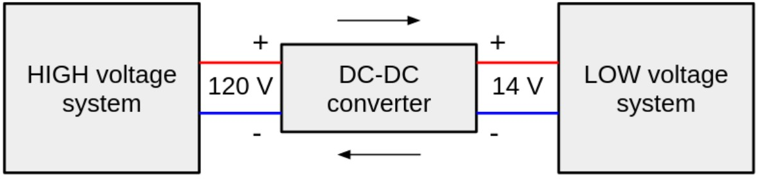

*Fig 1.1 Operational block diagram of DC/DC converter*

DC-DC converters can be divided into two categories according to whether there is electrical isolation between the input and output: those without electrical isolation are called non-isolated DC-DC converters, and those with electrical isolation are called isolated DC-DC converters. Non-isolated DC-DC converters can be divided into three categories: single-tube, double-tube and four-tube, according to the number of active power devices used.

#### 1.1.1 Magnetic Converters

In these DC-to-DC Converters, energy is periodically stored and released from a magnetic field in an inductoror a transformer. The frequency ranges from 300 kHz to 10MHz**.** By maintaining the duty cycle of the charging voltage the amount of power that needs to be transferred continuously to a load can be more easily controlled. Moreover, the control can also be applied to the input current, the output current or to maintain constant power through the circuit. The transformer-based converter can easily provide the isolation between input and output.

#### 1.1.2 Non-Isolated Converters

The non-isolated converters type is generally used where the voltage needs to be stepped up or down by a relatively small ratio (less than 4:1). And when there is no problem with the output and input having no dielectric isolation. There are five main types of converters in this non-isolated group, usually called the buck, boost, buckboost, Cuk and charge-pump converters. The buck converter is used for voltage stepdown, while the boost converter is used for voltage step-up. The buck-boost and Cuk converters can be used for either step-down or step-up. The charge-pump converter is used for either voltage step-up or voltage inversion, but only in relatively low power applications.

#### 1.1.3 Isolated converters

Usually, in this type of converters a high frequency transformer is used. In the applications where the output needs to be completely isolated from the input, an isolated converter is necessary. There are many types of converters in this group such as HalfBridge, Full-Bridge, Fly-back, Forward and Push-Pull DC/DC converters . All of these converters can be used as bi-directional converters and the ratio of stepping down or stepping up the voltage is high.

#### 1.1.4 Linear and Switched converters

A DC/DC converter is class of [power supply](https://www.arrow.com/categories/power-supplies) that converts a source of direct current (DC) from one voltage level to another. There are two types of DC/DC converters: linear and switched. A linear DC/DC converter uses a resistive voltage drop to create and regulate a given output voltage, a switched-mode DC/DC converts by storing the input energy periodically and then releasing that energy to the output at a different voltage. The storage can be in either a magnetic field component like an inductor or a transformer, or in an electric field component such as a [capacitor.](https://www.arrow.com/en/categories/capacitors) Transformer-based converters provide isolation between the input and the output.

Switch mode converters offer three main advantages:

* The power conversion efficiency is much higher.
* Because the switching frequency is higher, the passive components are smaller and lower losses simplify thermal management.
* The energy stored by an inductor in a switching regulator can be transformed to output voltages that can be smaller than the input (step-down or buck), greater than the input (boost), or buck-boost with reverse polarity (inverter).
* The storage can be in either a magnetic field component like an inductor or transformer.

Unlike a switching converter, a linear converter can only generate a voltage that is lower than the input voltage. While there are many advantages, there are also some disadvantages with switching DC/DC converters. They are noisy as compared to a linear circuit and require energy management in the forms of a control loop. Fortunately, modern switching-mode controller chips make the control task easy.

#### 1.1.5 Buck Converter

DC-DC buck converter is shown in fig 1.2 which steps down the applied DC input voltage level directly. By directly means that buck converter is non-isolated DC converter. Non-isolated converters are ideal for all board level circuits where local conversion is required. Fax machines, scanners, Cell phones, PDAs, computers, copiers are all examples of board level circuits where conversion may require at any level inside the circuit. Hence, a buck converter converts the DC level of input voltage into other required levels.

Buck converter is having a wide range of use in low voltage lowpower applications. Multiphases of buck converters can provide high current with low voltage. Therefore, it can be used for low voltage high power applications. This article will discuss both low voltage low power converter and low voltage high power converter. The basic buck converter consists of a controlled switch, a diode, capacitor and controlled driving circuitry. The switch controls the flow of input power into output by turning ON and OFF periodically. The time for which the switch is ON during the whole period is known as Duty cycle**.** The basic buck converter consists of a controlled switch, a diode, capacitor and controlled driving circuitry.

The value of duty cycle D ranges between 0 and 1. For D=0, zero voltage appear across load while for D=1, all the input voltage appears across the load. That’s why buck converter is operated for D greater than 0 and less than 1. The basic circuit diagram of buck converter can be seen below.

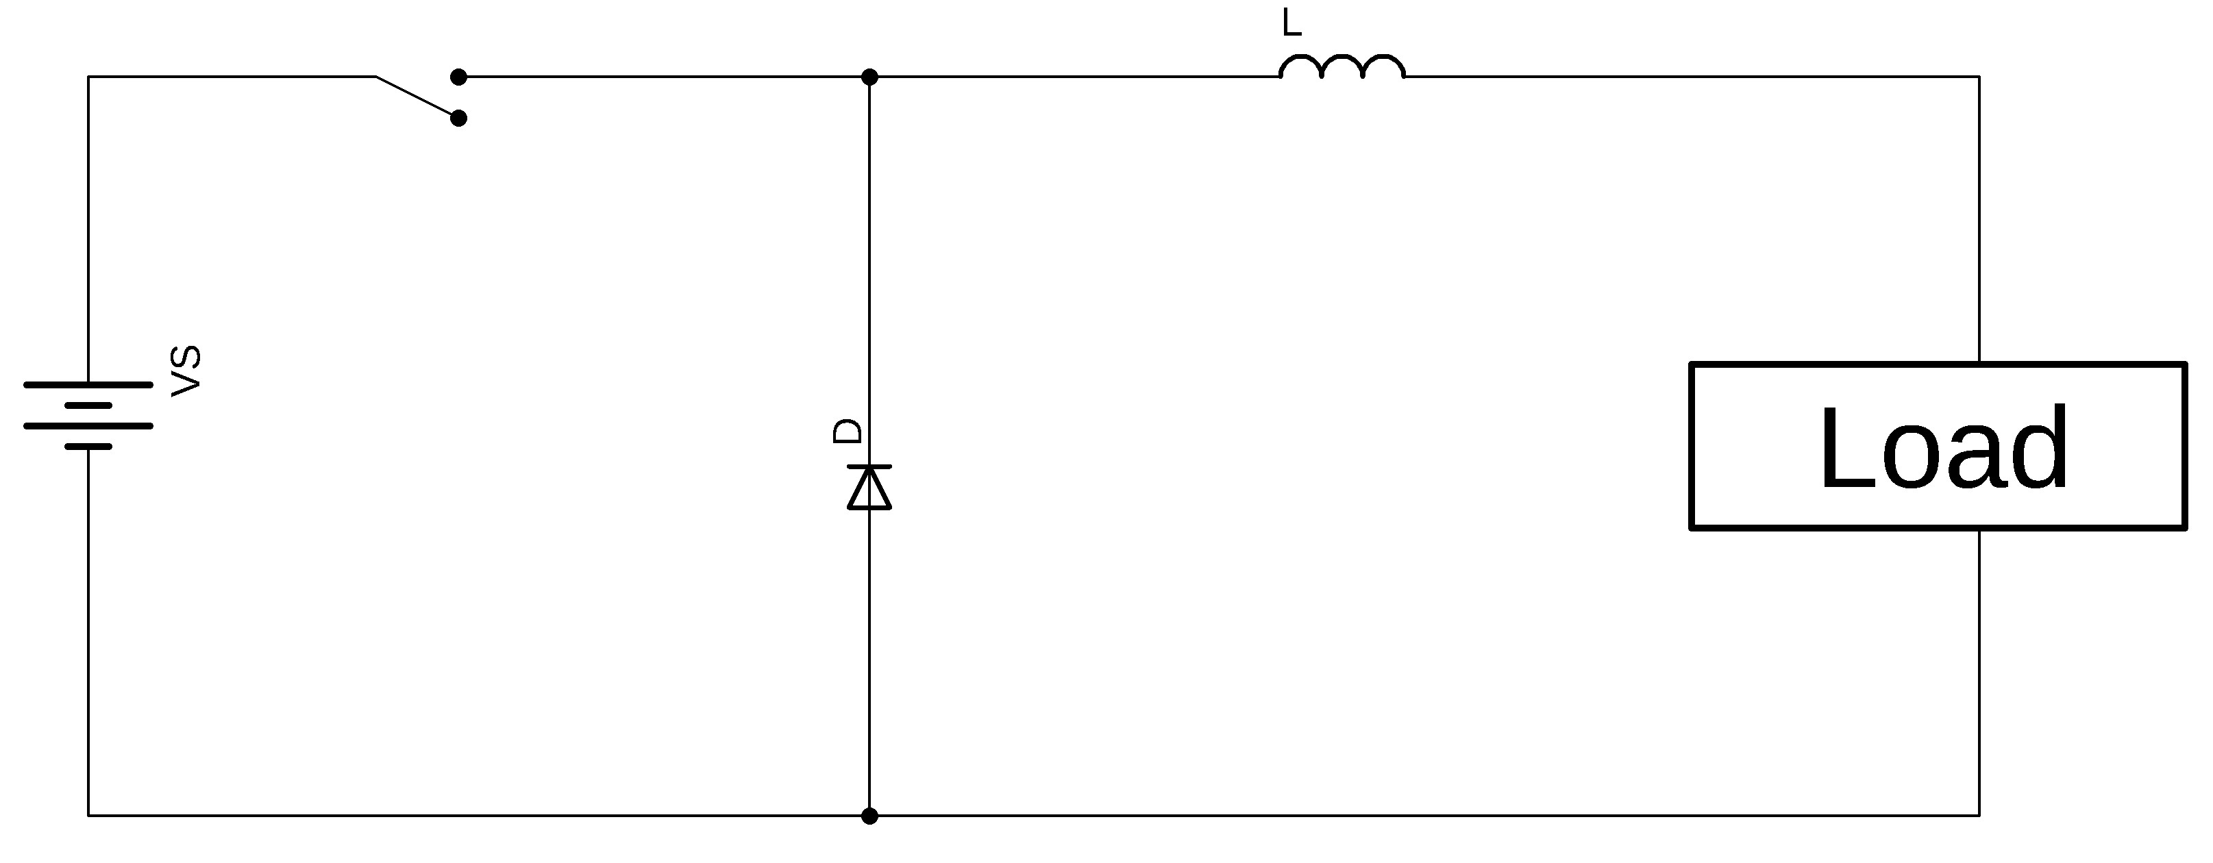

*Fig 1.2: Buck converter*

A buck converter operates in two types of conduction modes i.e., CCM and DCM. In CCM (**C**ontinuous **C**onduction **M**ode) the inductor current IL remains positive throughout the switching period. This article will discuss both low voltage low power converter and low voltage high power converter.

#### 1.1.6 Boost Converter

DC-DC boost converter is shown in fig 1.3. They can produce voltage higher than the input voltage. In a typical boost converter, the induction coil receives almost all the current, while the closed diode doesn’t let the current charge the capacitor and the load. Due to a higher electric current, the coil accumulates much more magnetic field energy compared to a step-down schematic. When the voltage drops to a certain point, the power key is turned off, while the diode is turned on. The input voltage adds to the energy stored in the coil, which makes the output voltage of boost DC-DC converters higher than the input voltage.

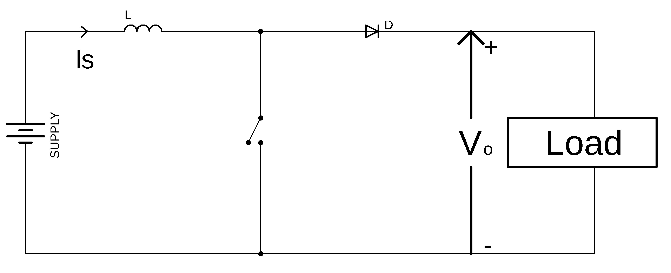

*Fig 1.3: Boost converter*

Boost converters are used whenever you can’t provide a high enough input voltage with batteries or there’s simply not enough room for more batteries. They are typically used in hybrid vehicles, lighting systems that use energy-saving lamps, portable lighting devices, etc.

##### 1.1.7 Buck – Boost Converter

The buck–boost converter is a DC-to-DC converter (also known as a chopper) is shown in fig 1.4 with an output voltage magnitude that is either greater than or less than the input voltage magnitude. It is used to “step up” the DC voltage, similar to a transformer for AC circuits. It is equivalent to a flyback converter using a single inductor instead of a transformer. Two different topologies are called buck–boost converter. They are typically used in hybrid vehicles, lighting systems that use energy-saving lamps.

DC-DC converters are also known as choppers. Here we will have a look at Buck Boost converter which can operate as a DC-DC Step-Down converter or a DC-DC Step-Up converter depending upon the duty cycle, D. An inductor will be connected in parallel with the output terminals and a diode is connected similarly to that as seen in the boost converter. The solid-state device which is basically a semiconductor device will act as the switching device.

The working operation of the DC to DC converter is the inductor in the input resistance has an unexpected variation in the input current. If the switch is ON then the inductor feeds the energy from the input and it stores the energy of magnetic energy. If the switch is closed it discharges the energy. The output circuit of the capacitor is assumed as high sufficient than the time constant of an RC circuit is high on the output stage. The huge time constant is compared with the switching period and make sure that the steady state is a constant output voltage Vo(t) = Vo(constant) and present at the load terminal.

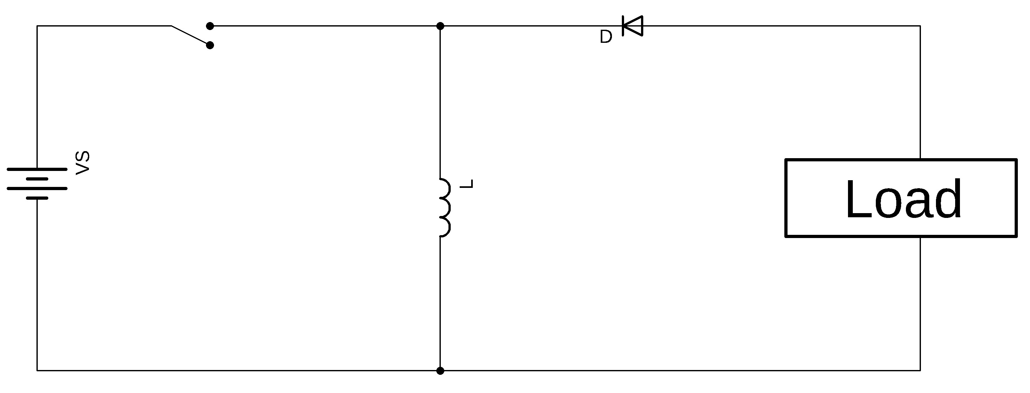

*Fig 1.4 Buck-Boost converter*

There are two different types of modes in the buck boost converter. The following are the two different types of buck boost converters.

* Continuous conduction mode.
* Discontinuous conduction mode.
* Continuous Conduction Mode:

In the continuous conduction mode, the current from end to end of inductor never goes to zero. Hence the inductor partially discharges earlier than the switching cycle.

* Discontinuous Conduction Mode:

In this mode the current through the inductor goes to zero. Hence the inductor will totally discharge at the end of switching cycles.

### 1.2 Advantages and Disadvantages of DC-DC Converters

This section includes the main advantages and disadvantages of DC to DC converters. The proposed converter also posses some of the major advantages mentioned below.

#### 1.2.1 Advantages

It simplifies the power supply systems in the circuit.

* It provides isolation in the primary and secondary circuits from each other.
* It provides a technique to extend potential (voltage) as required.
* It is available as a hybrid circuit with all elements in a single chip.
* It is also used in the regulation and control of DC voltage.
* The output is well organized as positive or negative.
* Battery space can be reduced by using a converter.

#### 1.2.2 Disadvantages

* Switching converters lead to more noise.
* They are expensive as an external circuit is required.
* Choppers are inadequate due to unsteady voltage and current supply.
* More ripple current, More input and output capacitance, higher losses, etc.

### 1.3 Fuel cell

A fuel cell uses the chemical energy of hydrogen or other fuels to cleanly and efficiently produce electricity. If hydrogen is the fuel, the only products are electricity, water, and heat. Fuel cells are versatile and power applications across multiple sectors, including transportation, industrial/commercial/residential buildings, and long-term energy storage for grids in reversible systems.

Fuel cells offer several advantages over traditional combustion-based technologies used in many power plants and vehicles today. Fuel cells operate at a higher efficiency than internal combustion engines, converting the chemical energy of fuels directly into electrical energy, with efficiencies exceeding 60%. Fuel cells have low or no emissions compared to internal combustion engines. Hydrogen fuel cells only emit water and no carbon dioxide, addressing a significant climate challenge. There are no air pollutants that create smog on the job site and cause health problems. Since fuel cells have few moving parts, they are quiet during operation.

Fuel cells work like batteries, but they do not self-discharge and do not require recharging. They generate electricity and heat as long as fuel is provided. A fuel cell consists of two electrodes – a cathode (or anode) and an anode (or cathode) – sandwiched around an electrolyte. Fuel, such as hydrogen, is introduced into the anode and air is introduced into the cathode. In a hydrogen fuel cell, a catalyst at the anode splits hydrogen molecules into protons and electrons, which follow different paths to the cathode. The electrons pass through an external circuit, creating an electric current. The protons move through the electrolyte to the cathode, where they combine with oxygen and electrons to produce water and heat. Fuel cells have low or no emissions compared to internal combustion engines. Up to date, hydrogen is being stored in compressed gas cylinders and liquid tanks. Innovative approaches, including chemical hydrides, carbon systems, and hydrogen absorption through metal hydrides, still require significant improvement in terms of capacity and safety. Even if the storage system design becomes as efficient as expected and affordable, the refuelling infrastructure needs to be widespread enough to make hydrogen available to millions of vehicle owners.

### 1.4 DC/DC Converters for Electric Vehicles

The different configurations of EV power supply show that at least one DC/DC converter is necessary to interface the FC, the Battery or the Supercapacitors module to the DC-link.

In electric engineering, a DC-DC converter is a category of power converters and it is an electric circuit which converts a source of direct current (DC) from one voltage level to another, by storing the input energy temporarily and then releasing that energy to the output at a different voltage. The storage may be in either magnetic field storage components (inductors, transformers) or electric field storage components (capacitors).

DC/DC converters can be designed to transfer power in only one direction, from the input to the output. However, almost all DC/DC converter topologies can be made bi-directional. A bi-directional converter can move power in either direction, which is useful in applications requiring regenerative braking. A wide variety of DC-DC converters topologies, including structures with direct energy conversion.

The amount of power flow between the input and the output can be controlled by adjusting the duty cycle (ratio of on/off time of the switch). Usually, this is done to control the output voltage, the input current, the output current, or to maintain a constant power. Transformer-based converters may provide isolation between the input and the output. The main drawbacks of switching converters include complexity, electronic noise and high cost for some topologies. **1.4.1 Electric Vehicle Converters Requirements**

As shown in fig1.5, In case of interfacing the Fuel Cell, the DC/DC converter is used to boost the Fuel Cell voltage and to regulate the DC-link voltage. However, a reversible DC/DC converter is needed to interface the SCs module. A wide variety of DC-DC converters topologies, including structures with direct energy conversion, structures with intermediate storage components (with or without transformer coupling), have been published. However, some design considerations are essential for automotive applications:

* Light weight
* High efficiency
* Small volume
* Less size
* Low electromagnetic interference
* Low current ripple drawn from the Fuel Cell or the battery

The step-up function of the converter, Control of the DC/DC converter power flow subject to the wide voltage variation on the converter input.

Each converter topology has its advantages and its drawbacks. For example, The DC/DC boost converter does not meet the criteria of electrical isolation. Moreover, the large variance in magnitude between the input and output imposes severe stresses on the switch and this topology suffers from high current and voltage ripples and also big volume and weight. A basic interleaved multichannel DC/DC converter topology permits to reduce the input and output current and voltage ripples, to reduce the volume and weight of the inductors and to increase the efficiency. These structures, however, cannot work efficiently when a high voltage step-up ratio is required since the duty cycle is limited by circuit impedance leading to a maximum step-up ratio of approximately.

Hence, two series connected step-up converters would be required to achieve the specific voltage gain of the application specification. A full-bridge DC/DC converter is the most frequently implemented circuit configuration for fuel-cell power conditioning when electrical isolation is required. The full bridge DC/DC converter is suitable for high-power transmission because switch voltage and current are not high.

It has small input and output current and voltage ripples. The full-bridge topology is a favourite for zero voltage switching (ZVS) pulse width modulation (PWM) techniques.

Block Diagram of FCEV is shown in fig 1.5. Basic interleaved multichannel DC/DC converter topology permits to reduce the input and output current and voltage ripples, to reduce the volume and weight of the inductors and to increase the efficiency. Usually, this is done to control the output voltage, the input current, the output current, or to maintain a constant power. The full bridge DC/DC converter is suitable for highpower transmission because switch voltage and current are not high. It has small input and output current and voltage ripples. Transformer-based converters may provide isolation between the input and the output. Hydrogen fuel cells only emit water and no carbon dioxide, addressing a significant climate challenge.

Power

Conversion

Stage

Fuel Cell

Battery

Controller

Traction

Motor

Transmission

Wheels

*Fig 1.5: Block diagram of fuel cell electric vehicle*

#### 1.4.2 Key Components of a Hydrogen Fuel Cell Electric vehicle

1. Battery (auxiliary): In an electric drive vehicle, the low-voltage auxiliary battery provides electricity to start the car before the traction battery is engaged; it also powers vehicle accessories.
2. Battery pack: This high-voltage battery stores energy generated from regenerative braking and provides supplemental power to the electric traction motor.
3. DC/DC converter: This device converts higher-voltage DC power from the traction battery pack to the lower-voltage DC power needed to run vehicle accessories and recharge the auxiliary battery.
4. Electric traction motor (FCEV): Using power from the fuel cell and the traction battery pack, this motor drives the vehicle’s wheels. Some vehicles use motor generators that perform both the drive and regeneration functions.
5. Fuel filler: A nozzle from a fuel dispenser attaches to the receptacle on the vehicle to fill the tank. vi. Fuel tank (hydrogen): Stores hydrogen gas onboard the vehicle until it’s needed by the fuel cell.
6. Power electronics controller (FCEV): This unit manages the flow of electrical energy delivered by the fuel cell and the traction battery, controlling the speed of the electric traction motor and the torque it produces.
7. Thermal system (cooling) – (FCEV): This system maintains a proper operating temperature range of the fuel cell, electric motor, power electronics, and other components.
8. Transmission (electric): The transmission transfers mechanical power from the electric traction motor to drive the wheels.

### 1.5 Literature Review

DC to DC converters is used in portable electronic devices such as cellular phones and laptop computers, which are supplied with power from batteries primarily. Such electronic devices often contain several sub-circuits, each with its own voltage level requirement different from that supplied by the battery or an external supply (sometimes higher or lower than the supply voltage). Additionally, the battery voltage declines as its stored energy is drained. Switched DC to DC converters offer a method to increase voltage from a partially lowered battery voltage thereby saving space instead of using multiple batteries to accomplish the same thing. Currently, dc/dc converters are used in most industrial applications. However, for fuel cell based energy systems, a step-up dc/dc boost converter is mandatory to boost the low voltage to higher level to enable grid integration or supply power to an islanded load. Provide high voltage gain by controlling the turns ratio of the transformer.

In most of the practical cases, the converter is configured to generate output voltage around 400 V, with input voltage only ranging from 18 to 50 V [1–3]. In ideal scenarios, the voltage gain of the classical boost converter is infinite. However, practically, its step-up ability is limited and restricted by the power device’s parasitic components, capacitance and inductance, and conduction losses caused by resistances and diode voltage drops. Another limitation for having such a high step-up ratio is that triggering the power switch during the high duty cycle may causes reverse recovery problems and magnetic saturation issues [4–6]. Several papers have been published in the literature, attempting to create boost converters with high gain and high efficiency [7–12]. Step-up dc/dc converters can be classified based on the inclusion of a transformer that isolated vs. non-isolated. Topologies that include a transformer can provide high voltage gain by controlling the turns ratio of the transformer. Moreover, transformers provide isolation between the output and input sides.

Transformer less topologies are competitive in terms of cost, weight, and design simplicity [10]. Topology presented in this project, which is based on cascading boost converters, is able to achieve higher voltage gain without an extreme duty cycle as compared to the classical boost converter; however, its switching devices are under high voltage/current stress. Another possible solution for providing a higher voltage gain is the use of switched inductors/capacitors [13–14]. A switched inductor converter has a voltage gain double of that reported for the classical boost converter; however, its semiconductors are under high voltage stress. In some papers, voltage lift methodology is applied [15-16] in order to achieve high voltage-gain, as well as reduce voltage/current stress on the switches. However, multiple diodes and capacitors are required when the conversion ratio is high. Isolated topologies, such as coupled inductors and flyback converters, use the turns ratio, in addition to the duty cycle, to control the converter voltage gain. As the required step-up ratio is performed at moderate duty cycle, the overall efficiency is increased. However, in topologies such as the flyback converter, voltage spikes on the active switch appear due to the discharging energy of leakage inductance.

Increasing dissipations are the inevitable result of the discharging energy of leakage inductance on the active switch. Different solutions for such problems exist such as the employment of active clamp circuits (considered a costly solution) and passive clamp circuits [17-19]. Switched capacitor converters are used to provide boosting ability without any magnetic components [18-20]. Hard switching switched capacitor boost converters suffer from low efficiency, less than 75%, as reported in [20]. Adding a resonance inductor improves the switched capacitor performance [2122]. The boosting range is still somewhat limited compared to converters with inductors, the duty cycle of which can be varied for a wide range of boosting. In this paper, a new dc/dc converter with high step-up ability is proposed. The proposed converter is well suited for different applications, such as fuel cell-based systems.

### 1.6 Problem Formulation

Fuel **c**ells are the most important sources of energy. There is a problem since the voltages produced by the fuel cell much below acceptable values and are very dependent on factors like temperature. The fuel cell systems need high voltage gain converters. Boost converters, switched-capacitor converters and switched conductors are used to achieve higher voltage gain, efficiency and low voltage stress. In this project an ultra-Voltage gain DC-DC converter is proposed with fuel cell as energy system.

High voltage gain is achieved through the proposed converter.

### 1.7 Objective of the Project

The main objective of this project is to propose a new dc/dc boost configuration with high voltage-gain capability for Fuel cell converters. The proposed converter should have low voltage stress and ripples. The complete analysis is validated by implementing a prototype on Simulink.

### 1.8 Organization of the Project

1. Chapter-1: This chapter mainly deals with the working principle and detailed information about various types of DC-DC converters.
2. Chapter-2: This chapter mainly deals with the detailed operation of the proposed High gain step up converter.
3. Chapter-3: This chapter mainly deals with the design analysis of proposed converter.
4. Chapter-4: This chapter mainly deals with the theoretical analysis and simulation results of Proposed Converter.
5. Chapter-5: This chapter mainly deals with the conclusions and future scope of the project.

### 1.9 Summary

This chapter clearly elaborates the basic introduction of DC – DC converters, Fuel cell and their advantages and disadvantages. The literature survey of the present step-up technologies are also given with recent advancements.

## CHAPTER 2 PROPOSED HIGH STEP-UP CONVERTER

### 2.1 Introduction

The configuration of the proposed converter is depicted in fig 2.1. It consists of two diodes, three inductors, two capacitors, and three switches. The three switches are triggered on and off simultaneously. The two-diodes are operated in a complementary manner to the switches in order to provide a free path for the inductor current. Inductors charge in parallel when the switches are turned on and discharge their energy to the output load once switches are turned off. In the upcoming analysis, the small-ripple approximation is used. The converter is designed to operate in the continuous conduction mode (CCM). The parameters are assumed to be ideal for the upcoming analysis in order to facilitate the analysis of the converter. A graph of the ideal key waveforms of the circuit devices is shown in fig 2.2. The two possible operating modes of the converter are discussed as follows:

Fuel

cell

L

x

CH

x

D

x

C

x

L

y

L

z

CH

y

CH

z

C

y

R

D

y

Basic

Boost

Converter

Ste

p

Boosti

n

g

cell

Output Filter

*F*

*ig*

*2.1:*

*The*

*proposed configuration*

*circuit*

The Proposed converter has mainly three sections:

* Basic Boost converter
* Step Boosting cell
* Output filter

The combination of the above three sections form the Proposed converter with high voltage gain, high efficiency, lower voltage stresses and lower current stresses. The converter is designed to operate in the continuous conduction mode (CCM).The Proposed converter operates in two modes. The characteristic equations that describe this mode of operation in the following.

V

CHX

V

CHY

=

V

CHZ

V

Dx

V

Dy

i

Lx

i

Ly

=

i

Lz

DT

s

T

s

*Fig 2.2 The ideal key waveforms of the converter*

### 2.2 Modes of operation

The detailed operation of the proposed converter for various modes is discussed in the following sections.

#### 2.2.1 Mode 1

This mode is activated once the switches are turned on, and the depiction of this mode is illustrated in fig 2.3. The three switches are turned on simultaneously. In this mode, inductor *L*x is energized from the input dc-source, while inductors *L*y and *L*z are energized from capacitor *C*x. Diodes *D*x and *Dy* are reversely biased. Output capacitor *Cy* releases its energy to the load side. The characteristic equations that describe this mode of operation in the following.

#### 2.2.3 Mode-2

This mode is activated once the switches are turned off, and the depiction of this mode is illustrated in fig 2.4. The three switches are turned off at the same time. In this mode, inductor *L*x is discharging its energy into capacitor *C*x , while inductors *L*y and *L*z are discharging their energy into output load and output capacitor *Cy*. In order to maintain a continuous path for the inductor currents, diodes *D*x and *Dy* work as freewheeling diodes when they are turned on. The characteristic equations that describe this mode of operation in the following circuit diagrams and with the proposed converter waveforms.

CxCy**+**Vo

L

y

CH

z

L

z

CH

y

Fuel

cell

L

x

-

CHx

VCy(t)+Vo(t)=0

Vin=VLx VCx(t)=VLy(t)=VLz(t) VCy(t)= -Vo(t)

Ly=Lz, iLy=iLz iCy(t)=VCy(t)/R= -V0(t)/R iCx=iLy+iLz=2iLy(t) iCx(t)=2iLy(t)

Fig 2.3 The configuration of mode I.

By KVL

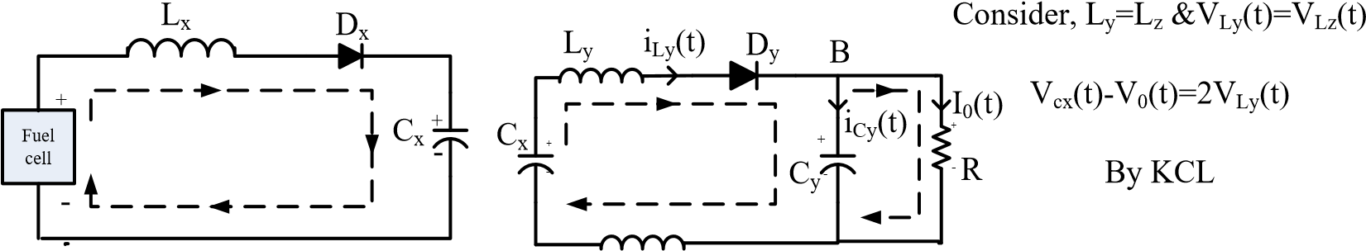Vcx(t)-VLy(t)-VLz(t)-V0(t)=0

i0(t)=V0(t)/R At node B:

|  |  |  |
| --- | --- | --- |
| Vin(t)=VLx(t)+VCx(t) VLx(t)=Vdc(t)-VCx(t) | Lz | iLy(t)=iCy(t)+i0(t) iCy(t)=iLy(t)-V0(t)/R |

At node A:

Fuel cell

L

x

C

x

C

y

R

L

y

L

z

D

y

D

x

A

i

Lx

(

t

)

+

-

-

-

+

+

i

Ly

(

t

)

i

Cx

(

t

)

iLx(t)=iLy(t)+iCx(t)

iCx(t)=iLx(t)-iLy(t)

*Fig2.4 The configuration of mode 2*

The voltage and current stresses of each component are depicted in Tables 2.1 and 2.2, respectively. All components have a voltage stress lower than the output voltage. This is a distinct advantage of this topology. It enables us to select the devices with low ratings, thus improving the overall efficiency of the system. However, multiple diodes and capacitors are required when the conversion ratio is high. Isolated topologies, such as coupled inductors and flyback converters, use the turns ratio, in addition to the duty cycle, to control the converter voltage gain. As the required step-up ratio is performed at moderate duty cycle, the overall efficiency is increased.

*Table 2.1: The voltage stresses of the switching devices.*

|  |  |
| --- | --- |
| **Switching Device** | **Peak Voltage Stress** |
| 𝐶𝐻𝑋 | *Vo* ∗ (1 − *D*)/(1 + *D*) |
| 𝐶𝐻𝑌 | *Vo*/(1 + *D*) |
| 𝐶𝐻𝑍 | *Vo*/(1 + *D*) |
| *Dx* | *Vo* ∗ (1 − *D*)/(1 + *D*) |
| *Dy* | 2 ∗ *Vo*/(1 + *D*) |

*Table 2.2: The current stresses of the switching devices*.

|  |  |
| --- | --- |
| **Switching Device** | **RMS Current Stress** |
| 𝐶𝐻𝑋 | *Iin* ∗√𝐷 |
| 𝐶𝐻𝑌 | (1 − *D*) ∗√𝐷 ∗ *Iin*/2 |
| 𝐶𝐻𝑍 | (1 − *D*) ∗ √𝐷∗ *Iin*/2 |
| **Freewheeling Diodes** | **Average Current Stress** |
| DX | *Iin* ∗ (1 − *D*) |
| Dy | (1 − *D*)2 ∗ *Iin*/2 |

Equations from tables 2.2 and 2.3 represents the relationship between the voltage across capacitor *C*1 and input/output voltages. The voltage and current stresses of each component are depicted in tables 2.1 and 2.2, respectively. All components have a voltage stress lower than the output voltage. This is a distinct advantage of this topology. It enables us to select the devices with low ratings, thus improving the overall efficiency of the system.

### 2.3 Summary

This chapter clearly elaborates the configuration of the proposed converter. It is also discussed about the modes of operation of the proposed converter with theoretical equations. This section also shows the circuit configurations and waveforms of the different modes. The voltage and current stresses of each component are also depicted.

## CHAPTER 3 DESIGN OF PROPOSED CONVERETR

### 3.1 Introduction

The proposed converter can be considered as a promising candidate for Electric vehicle applications, where high voltage-gain is required. The principle of operation and the steady-state analysis of the converter in the continuous conduction mode are presented. The design and selection of converter parameters, such as inductor and capacitor values, are based on the amount of ripple allowed on each element. The design of the proposed circuit parameters are illustrated in the following sections.

### 3.2 Inductor Lx Design

The inductor *L*x current is shown in fig 3.1. The average value of the inductor *L*x current is defined as *I*1 and the difference between the inductor peak and the average current is

∆*ILx*

i

Lx

(

t

)

l

1

DT

s

T

s

Δ

i

Lx

Δ

i

Lx

(

V

in

/

L

x

)

(

V

in

-

V

cx

/

)

L

x

*Fig 3.1 inductor Lx current*

Considering the first interval of the switching cycle, the ripple of inductor *L*x is given by

𝑉𝑖𝑛

2∆𝑖𝐿𝑋 = ( 𝐿𝑋 ) 𝐷𝑇𝑠 (3.1)

𝑉𝑖𝑛

𝐿𝑋 = (2∆𝑖𝐿𝑋) 𝐷𝑇𝑠 (3.2)

As Equation (3.2) describes, the inductance of *L*x depends on the input voltage *Vin*, duty cycle *D*, sample time *TS*, and inductor current ripple ∆*iL*x.

### 3.3 Inductor Ly and Lz Design

The inductor *L*y, which is similar to *Lz*, current is shown in fig 3.2. The average value of the inductor *L*y current is defined as *I*y and the difference between the inductor peak and the average current is ∆*iL*y. Considering the first interval of the switching cycle, the ripple of inductor *L*y is given by

𝑉𝑖𝑛 𝐷𝑇𝑠

2∆𝑖𝐿𝑌 = ( 𝐿𝑦 ) (1−𝐷) (3.3)

𝑉𝑖𝑛 𝐷𝑇𝑠

𝐿𝑌 = 𝐿𝑍 = (2∆𝑖𝐿𝑦) (1−𝐷) (3.4)

i

Ly

(

t

)

l

2

DT

s

T

s

Δ

i

Ly

Δ

i

Ly

(

V

in

/((

1

-

D

)

L

y

))

(

V

cx

-

V

o

)

/

(

2

L

y

)

*Fig 3.2 The inductors Ly and L3 currents.*

As Equation (3.4) describes, the inductance of inductors *L*2 and *L*3 depend on the input voltage *Vin*, duty cycle *D*, sample time *Ts*, and the inductor current ripple ∆*iL*2. The value of the peak to peak ripple of inductor current. The difference between the inductor peak and the average current is ∆*iL*y.

**3.4 Output Capacitor Cy-Design:**

The output voltage ripple of the converter is limited by the amount of ripple permitted on the capacitor *Cy* voltage. Consequently, capacitor *Cy* should be designed to ensure that the converter output voltage exhibits ripple within the permitted range.

The capacitor *Cy* voltage is expressed in fig 3.3, where *Vo* is the capacitor voltage average value and the difference between the capacitor peak and the average voltage is ∆*vo*. Considering the first interval of the switching cycle, the ripple of capacitor *Cy* is given by

𝑉𝑜  (3.5)

∆𝜐𝑜 = (2𝑅𝐶𝑦) 𝐷𝑇𝑠

𝑉𝑜

𝐶𝑦 = (2∆𝜐𝑜)DTs (3.6)

Δ

V

o

V

o

(

t

)

DT

s

T

s

-

(

V

o

/

RC

y

)

-

(

i

Ly

-

v

o

(

/

)

RC

o

)

*Fig3.3 The capacitor Cy output voltage*

As can be seen from Equation (3.6), the value of capacitor *Cy* depends on the output voltage *Vo*, duty cycle *D*, sample time *TS*, and the capacitor voltage ripple ∆*vo*.

### 3.5 Capacitor *Cx*Design

The design of capacitor *C*x is not straightforward; similar to capacitor *Cy*, its current is equal to the inductor *L*x current, but without the dc components (see fig 3.4). As seen in fig (3.3) , the capacitor *C*x voltage reaches its maximum and minimum limits at the two zero crossing points of is current waveforms.

Let ∆*Vc*x be the difference between the average and max value of the capacitor *C* voltage value; the relation between the total charge *q* and the peak-to-peak ripple of the capacitor *C*x voltage is

*q* = *C*x(2∆*vC*) (3.7)

i

Cx

(

t

)

0

DT

s

T

s

0

.

5

*

T

s

q

0

V

cx

(

t

)

V

cx

Δ

V

cx

(

t

)

***Fig3.4*** *The capacitor Cx current and voltage.*

The value of charge *q* is obtained by integrating the shaded area of the capacitor *C*1x current , and due to the symmetry of the capacitor, the current waveform *q* is given by:

𝑇𝑠 q = ∆𝑖𝐿 (3.8)

2

Substitute Equation (3.8) into Equation (3.7) and a solution for the voltage ripple peak amplitude yields

∆𝜐𝐶𝑋 = ∆8𝑖𝐿𝐶𝑇𝑠𝑋 (3.9)

Hence,

𝐶𝑋 = ∆8𝑖∆𝐿𝑋𝜐𝐶𝑇𝑠𝑋 (3.10)

The capacitor value depends upon on the inductor Lx current ripple, sampling time, and the permitted ripple on capacitor Cx.

### 3.6 Summary

This chapter clearly elaborates the detailed information about the design of the proposed circuit parameters. The principle of operation and the steady-state analysis of the converter in the continuous conduction mode are presented. Also explained the design of the Inductors, capacitors with necessary equations and waveforms.

## CHAPTER 4 RESULTS AND DISCUSSIONS

### 4.1 Introduction

An explanation of the Simulink model of the proposed converter is given in this chapter, which exhibits the output waveforms to support the claim of high gain and high efficiency.

Math Works has created Simulink (Simulation and Link) as an add-on to MATLAB. Multi-domain dynamic systems may be modelled and analysed using this graphical programming language.

*Table 4.1 Simulation component values*

|  |  |  |
| --- | --- | --- |
| Component | Description | Specification |
| Vin | Input Voltage | 20V |
| V0 | Output Voltage | 60V |
| LX | Inductor | 11.33µH |
| LY, LZ | Inductors | 17.17µH |
| CX | Input Capacitor | 20.83µF |
| CY | Output Capacitor | 500 µF |
| CHX, CHY, CHZ | IGBT | IRFP264 |
| DX | Power Diode | BYE72EW-200 |
| D0 | Output Diode | BYE72EW-200 |
| FS | Switching Frequency | 60KHz |
| P0 | Rated Output Power | 2.5KW |

Table 4.1 shows converter the input voltage is 20V. The projected converter is designed for an output power of 2.5KW, to reduce the converter size, it is advisable to take higher switching frequencies (fs), however for the proposed simulation and design 60 kHz frequency is considered. The proposed converter contains five energy elements which includes three inductors and two capacitors. With the considerable current and voltage ripples on the inductors and capacitors respectively, the energy component values are calculated and are observed. The considerable current and voltage ripples on the inductors and capacitors respectively.

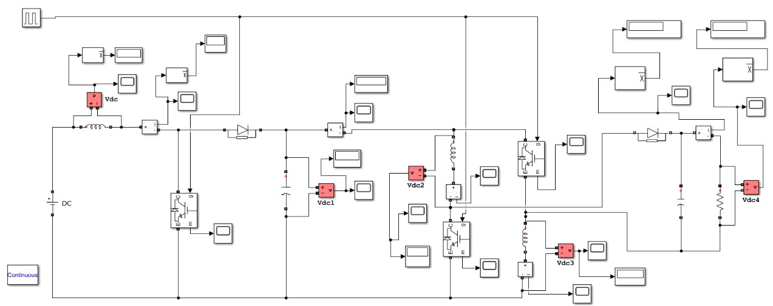

*Fig. 4.1 Simulation diagram of the proposed converter*

### 4.2 Simulation Waveforms of proposed converter

In this section, Using MATLAB software, simulated waveforms of various parameters such as switch voltage, waveforms, Capacitor voltage waveforms, diode voltage waveforms and output voltage waveforms are obtained clearly. By observing the nature of waveforms of proposed converter, its performance can be understood easily. Ripple content can be estimated. The simulation waveforms of proposed converter for different parameters are illustrated in below figures:

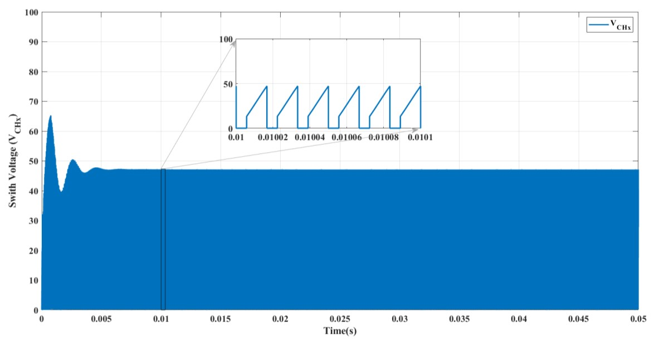

*Fig 4.2 Simulated waveform of Switch voltage stress* 𝑉𝐶𝐻𝑋

The fig 4.2 clearly shows the simulated Switch voltage stress waveform of Proposed converter. We can say that voltage stresses are lower in value of the Proposed converter. The main advantage of the proposed converter is the lower values of voltage stresses and current stresses.

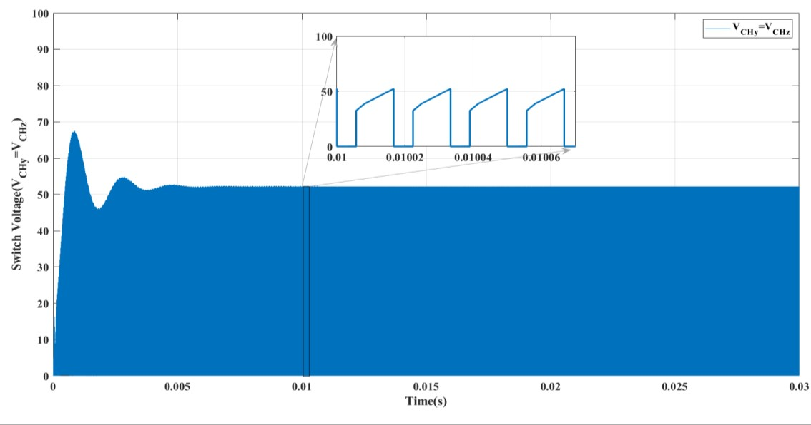

*Fig 4.3 Simulated waveform of switch voltage (*𝑉𝐶𝐻𝑌,𝑉𝐶𝐻𝑍)

The fig 4.3 clearly shows the simulated Switch voltage stress waveform of Proposed converter. We can say that voltage stresses are lower in value of the Proposed converter.

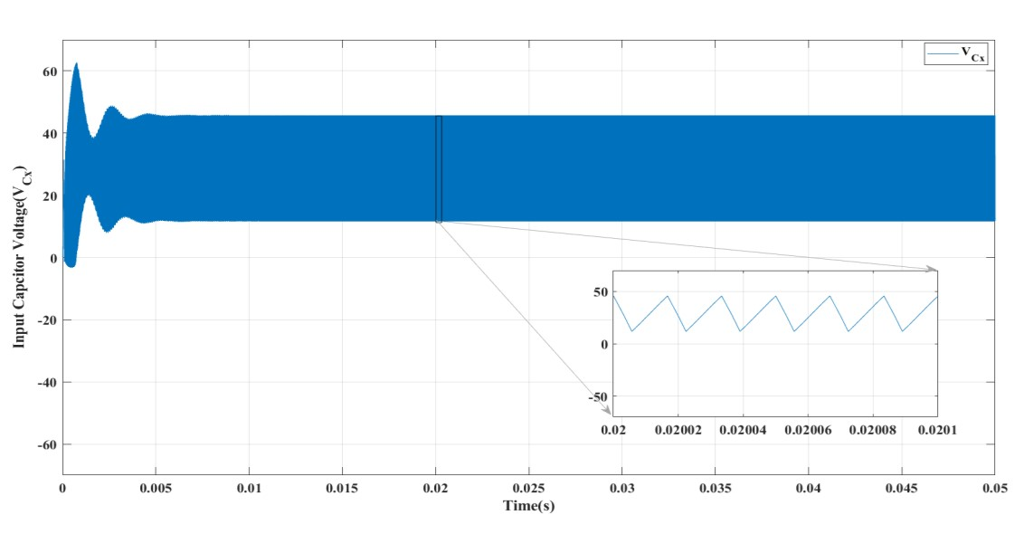

*Fig 4.4 Simulated waveform of input capacitor voltage (*𝑉𝐶𝑋)

The fig 4.4 clearly shows the simulated capacitor voltage stress waveform of Proposed converter. The value of ripple content obtained with the simulation is equal to theoretical analysis of the ripple value. The input capacitor voltage stress is simulated by using MATLAB software. By observing the nature of waveforms of proposed converter, its performance can be understood easily. Ripple content can be estimated. The possible solution for providing a higher voltage gain is the use of switched inductors or capacitors. These low rated components increase the overall efficiency of the system.

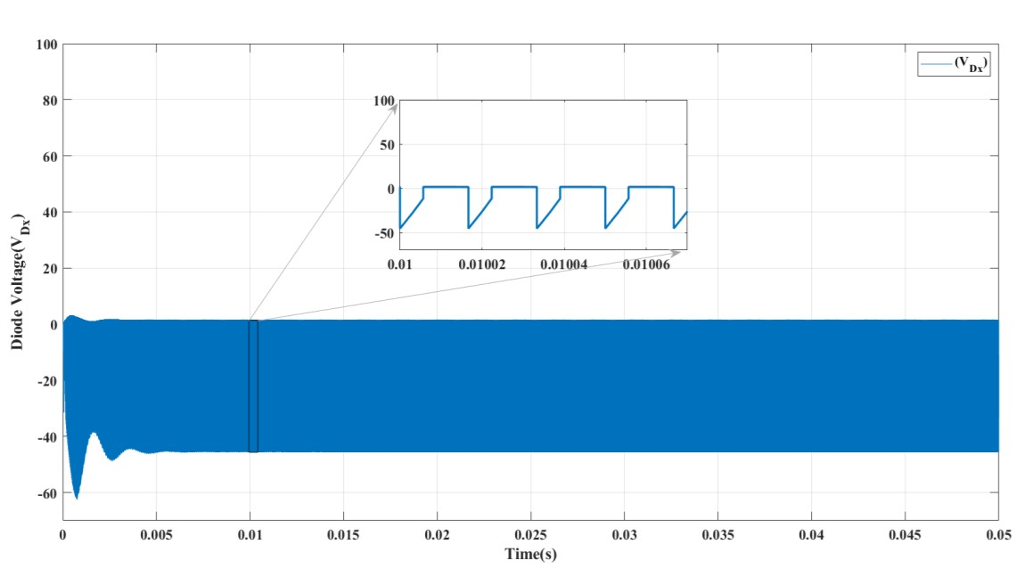

Fig 4.5 Simulated waveform of Diode voltage (𝑉𝐷𝑋)

The fig 4.5 clearly shows the simulated Diode voltage stress waveform of Proposed converter. We can say that Diode voltage stresses are lower in value of the Proposed converter. These are shown with negative values in the waveform.

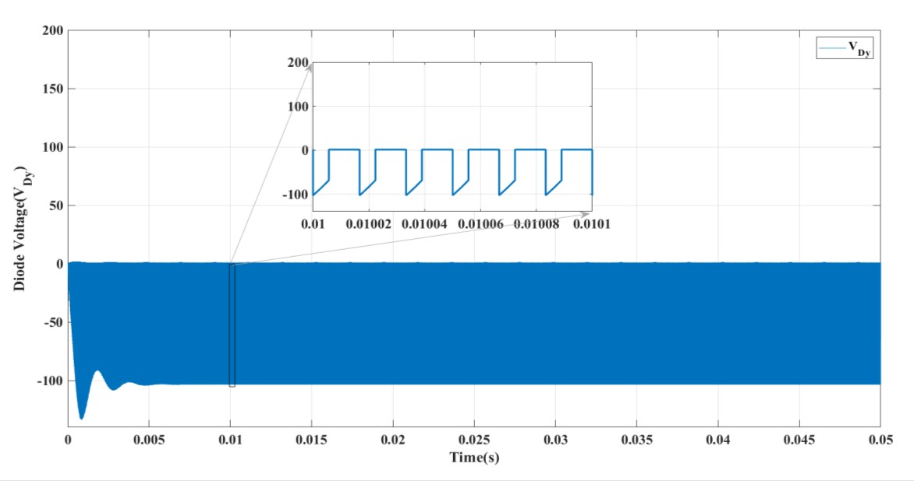

*Fig 4.6 Simulated waveform of Diode voltage(*𝑉𝐷𝑌)

The fig 4.6 clearly shows the simulated Diode voltage stress waveform of Proposed converter. We can say that Diode voltage stresses are lower in value of the Proposed converter. These are shown with negative values in the waveform. The above waveform is slightly different from the waveform shown in fig 4.5. The possible solution for providing a higher voltage gain is the use of switched inductors or capacitors. These low rated components increase the overall efficiency of the system.

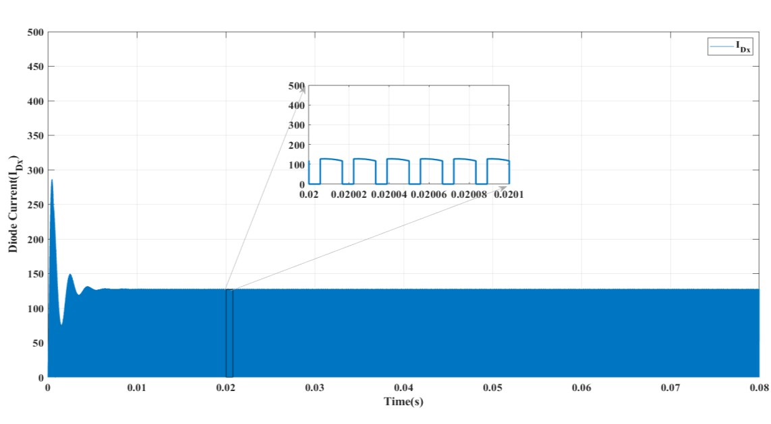

*Fig 4.7 Simulated waveform of Diode current (*𝐼𝐷𝑋)

The fig 4.7 clearly shows the simulated Diode current stress waveform of Proposed converter. We can say that Diode current stresses are lower in value of the Proposed converter. The ripple value is low.

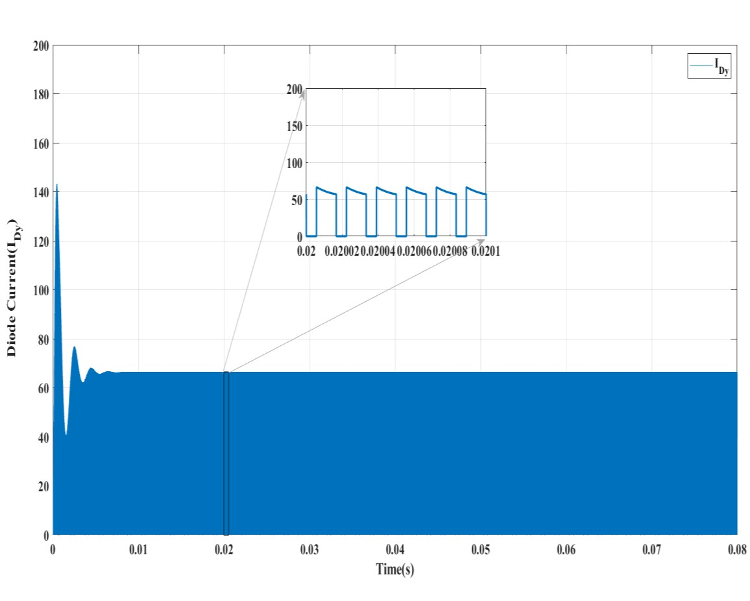

*Fig 4.8 Simulated waveform of Diode current (*𝐼𝐷𝑌)

The fig 4.8 clearly shows the simulated Diode current stress waveform of Proposed converter. We can say that Diode current stresses are lower in value of the Proposed converter. The ripple value is low. The output voltage waveform is shown in fig 4.9. The voltage gain of the proposed converter is high when compared to other converters topologies.

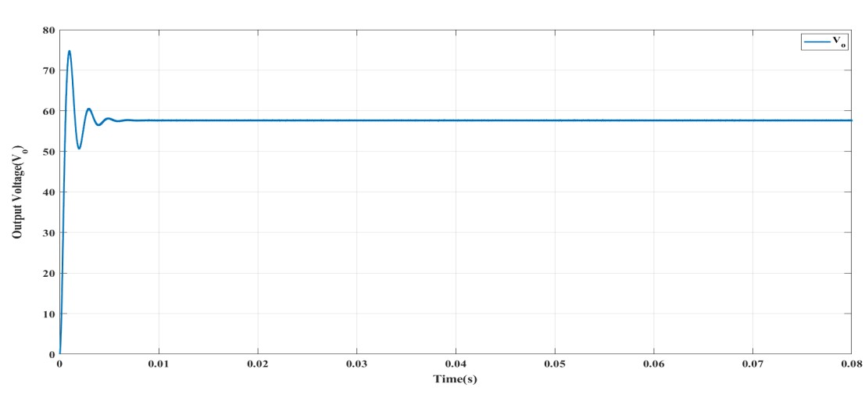

*Fig 4.9 Simulated waveform of Output voltage ( Vo)*

### 4.3 Characteristics of proposed converter

The characteristics of proposed converter should be studied in order to understand the Performance of Proposed converter. To know whether high voltage gain Can be obtained or not, whether efficiency is high or low, how much % percent of losses occur, graphs are plotted clearly for losses vs duty ratio, efficiency vs duty ratio, regulation.

*Table 4.2 Performance of Proposed converter*

|  |  |  |  |  |  |
| --- | --- | --- | --- | --- | --- |
| **D** | **VO** | **Io** | **Po** | **Pin** | **%η** |
| **10** | 25.9 | 18.03 | 468.23 | 489.6 | 95.6 |
| **15** | 30.38 | 21.09 | 640.71 | 671 | 95.4 |
| **20** | 35.66 | 24.77 | 883.29 | 928.4 | 95.1 |
| **25** | 42.11 | 29.25 | 1231.71 | 1301.4 | 94.6 |
| **30** | 49.97 | 34.7 | 1733.9 | 1847.6 | 93.8 |
| **34** | 57.56 | 39.97 | 2300.67 | 2476 | 92.91 |
| **35** | 59.67 | 41.44 | 2472.7 | 2668 | 92.6 |
| **40** | 71.59 | 49.72 | 3559.4 | 3912 | 90.9 |
| **45** | 82.26 | 57.12 | 4698.6 | 5276 | 89.05 |
| **50** | 89.24 | 61.98 | 5531 | 6340 | 87.7 |
| **55** | 97.34 | 67.6 | 6580.1 | 7752 | 84.8 |
| **60** | 106.9 | 74.2 | 7931.9 | 9692 | 81.8 |

The performance of the proposed converter is shown in the table 4.2. The values of output voltage, output current, output power, input power, efficiency and regulation for different duty ratios starting from 10 to 60 are simulated.

*Table 4.3 Switch Voltage Stresses of Proposed converter*

|  |  |  |  |  |  |  |
| --- | --- | --- | --- | --- | --- | --- |
| **D** | 𝑽𝑪𝑯𝑿**(Th)** | 𝑽𝑪𝑯𝑿**(si)** | 𝑽𝑪𝑯𝒀**(Th)** | 𝑽𝑪𝑯𝒀**(sim)** | 𝑽𝑪𝑯𝒁**(Th)** | 𝑽𝑪𝑯𝒁**(sim)** |
| **10** | 22.22222 | 22.28 | 24.69136 | 24.18 | 24.69136 | 24.18 |
| **15** | 23.52941 | 23.69 | 27.68166 | 26.82 | 27.68166 | 26.82 |
| **20** | 25 | 24.9 | 31.25 | 30.38 | 31.25 | 30.38 |
| **25** | 26.66667 | 26.6 | 35.55556 | 34.8 | 35.55556 | 34.8 |
| **30** | 28.57143 | 27.2 | 40.81633 | 39.8 | 40.81633 | 39.8 |
| **34** | 30.30303 | 30.35 | 45.91368 | 44.1 | 45.91368 | 44.1 |
| **35** | 30.76923 | 32.8 | 47.33728 | 45.4 | 47.33728 | 45.4 |
| **40** | 33.33333 | 35.5 | 55.55556 | 53.7 | 55.55556 | 53.7 |
| **45** | 36.36364 | 40.4 | 66.1157 | 60.7 | 66.1157 | 60.7 |
| **50** | 40 | 41.12 | 80 | 67.42 | 80 | 67.42 |
| **55** | 44.44444 | 46 | 98.76543 | 70.76 | 98.76543 | 70.76 |
| **60** | 50 | 54.4 | 125 | 77.2 | 125 | 77.2 |

The voltage stress values of the switches are shown in the table 4.3. The values of voltage stresses for different duty ratios starting from 10 to 60 are calculated and compared with both theoretical and simulated values.

The theoretical & simulated voltage stress values of the diode are shown in table 4.4. From the table 4.4, we can clearly say that theoretical values are matched with the simulated values. The voltage stresses across the diodes are lower in value. Voltage stress across the diode Dy is more compared to voltage stress across the diode Dx for all the duty ratio values. By observing the nature of waveforms of proposed converter, its performance can be understood easily. Ripple content can be estimated. We can say that switch voltage stresses are lower in value of the Proposed converter. The traditional boost converter has the minimum boosting capability, while the proposed converter has the highest gain among the different topologies.

*Table 4.4 Diode Voltage Stresses of Proposed converter*

|  |  |  |  |  |
| --- | --- | --- | --- | --- |
| **D** | **VDX(sim)** | **VDX(th)** | **VDY(sim)** | **VDY(th)** |
| **10** | 21.1 | 22.22222 | 47.6 | 49.38271 |
| **15** | 22.7 | 23.52941 | 53.2 | 55.36332 |
| **20** | 23.3 | 25 | 59.32 | 62.5 |
| **25** | 25.2 | 26.66666 | 68 | 71.1111 |
| **30** | 26.65 | 28.57143 | 78.2 | 81.63265 |
| **34** | 30.7 | 30.30303 | 82.5 | 91.82736 |
| **35** | 33.18 | 30.76923 | 86.7 | 94.67456 |
| **40** | 33.8 | 33.33333 | 94.8 | 111.1111 |
| **45** | 41.7 | 36.36364 | 122.4 | 132.2314 |
| **50** | 44.9 | 40 | 132.9 | 160 |
| **55** | 48.3 | 44.44444 | 141.2 | 197.5308 |
| **60** | 57.7 | 50 | 150.2 | 250 |

Fig 4.10 and 4.11 give the capacitor voltage stress and inductor current stress curves for various duty ratios of the proposed converter. It can be observed that as the value of the duty ratio is increasing, the capacitor voltages gets increases.

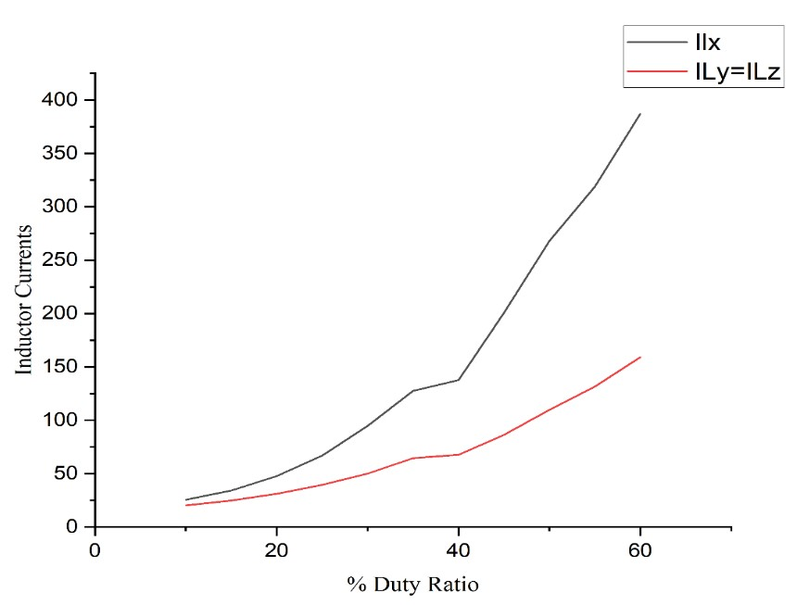

*Fig 4.10 Inductor currents*

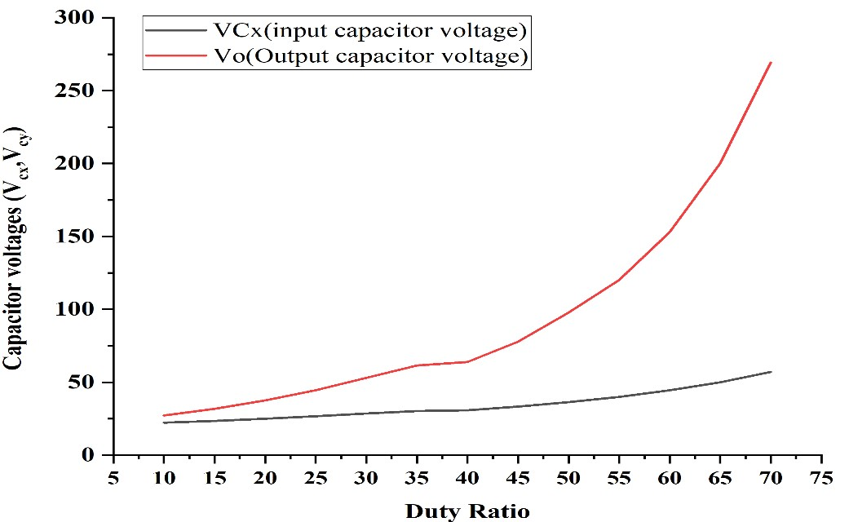

*Fig 4.11 Capacitor voltage (* 𝑉𝐶𝑋, 𝑉𝐶𝑌*)*

Fig 4.12 gives the switch voltage stress curve for various duty ratios of the proposed converter. It can be observed that as the value of the duty ratio is increasing, the switch voltage increases.

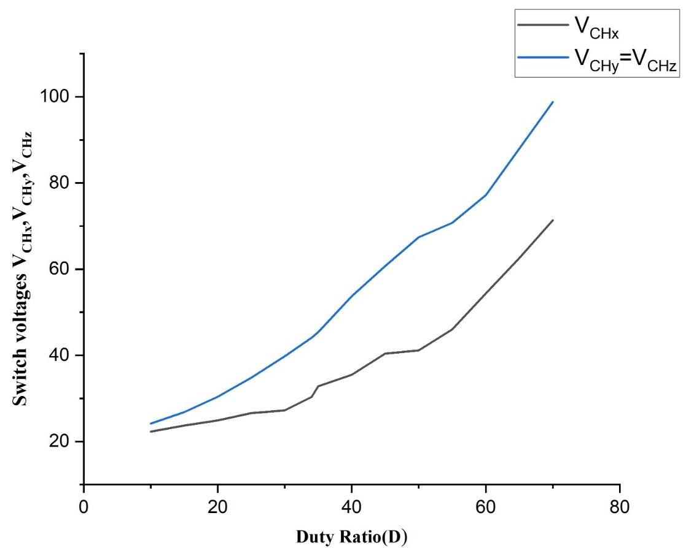

*Fig 4.12 Switch voltage* 𝑉𝐶𝐻𝑋,𝑉𝐶𝐻𝑌,𝑉𝐶𝐻𝑍

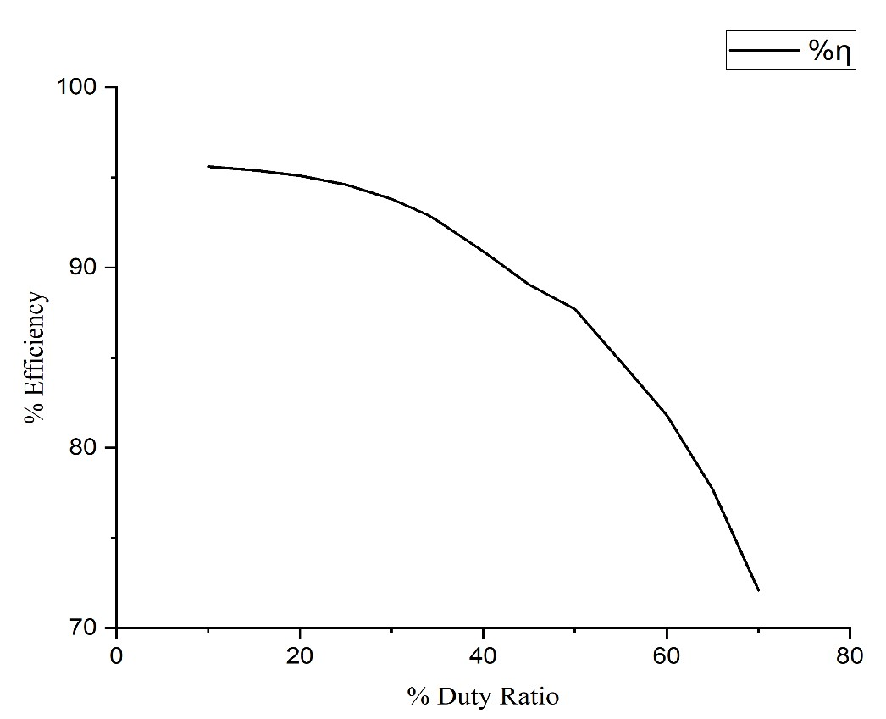

*Fig 4.13 Efficiency in percentage*

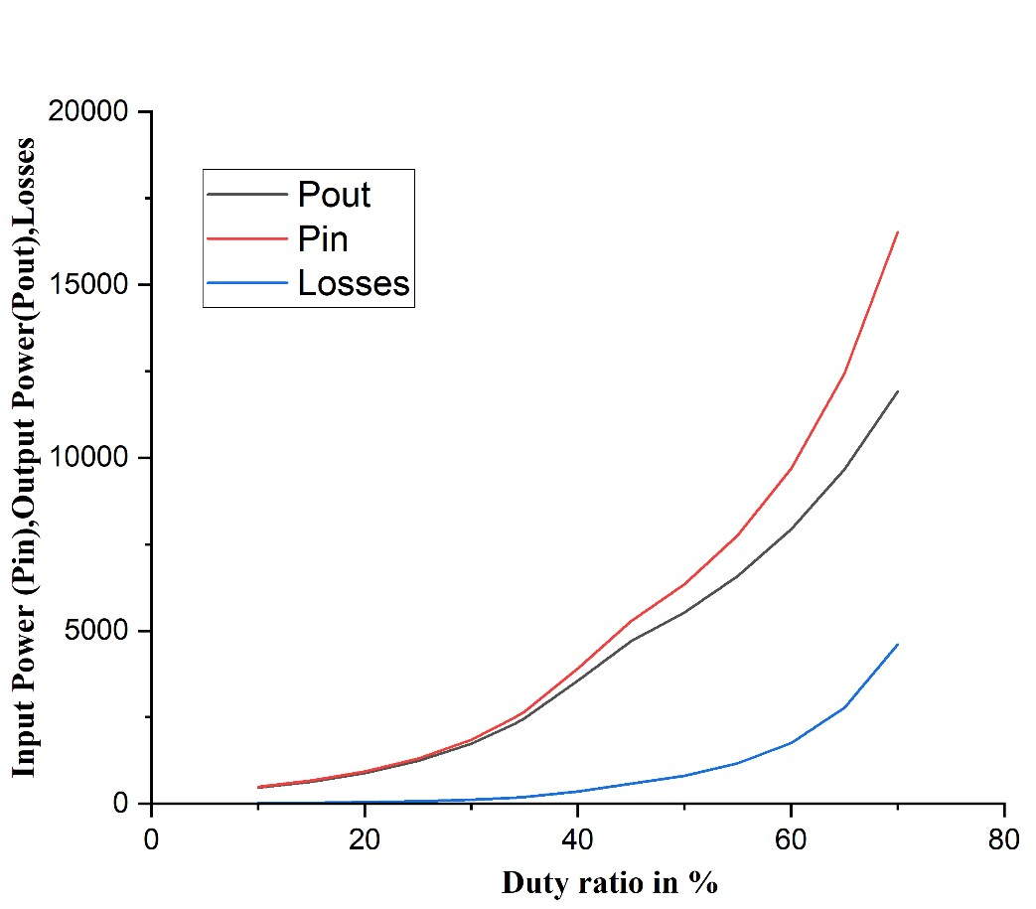

*Fig 4.14 Input power Pin, Output power Pout, Losses*

Fig 4.13 represent the efficiency of the proposed converter. The value of efficiency increases with increase in duty ratio then the efficiency curve decreases. The peak is observed at a point other than the operating point. It can be deduced that the overall efficiency of the converter is quite high which is more than 92% even for lower duty ratios.

Fig. 4.14 gives the input power, output power and power losses of the proposed converter. We know that input power – output power = losses. Losses should be lower in value in order to increase the efficiency. It can be observed that the losses are very low for the proposed converter for various duty ratios.

### 4.4 Comparison of Proposed Converter With Different Topologies

The merits & demerits of proposed converter can be clearly understood by plotting characteristics Curves such as output voltage vs duty ratio, diode stress vs duty ratio, voltage gain vs duty ratio, and different topologies. High-gain DC-DC converters also find their applications in fuel cells, electric vehicles, battery energy storage, automotive industries, and uninterrupted power supplies. The following are the comparison of the characteristics curves which helps us to know the performance level of proposed converter when compared to other different topologies. High-gain DC-DC converters also find their applications in fuel cells, electric vehicles, battery energy storage, automotive industries, and uninterrupted power supplies.

The proposed converter is suitable for different applications, such as Electric Vehicle applications and has some distinct advantages including a high step-up capability, low voltage stress and high efficiency. DC-DC converters are also referred to as linear or switching regulators, depending on the method used for conversion.There is a broad range of operating voltages for various electronic devices, such as ICs and MOSFETs, which necessitates providing voltage for each. A Buck Converter provides a lower voltage than the original voltage, while a Boost Converter supplies a higher voltage. DC/DC converters can be designed to transfer power in only one direction, from the input to the output. However, almost all DC/DC converter topologies can be made bi-directional. A bi-directional converter can move power in either direction, which is useful in applications requiring regenerative braking. The following are the comparison of the characteristics curves which helps us to know the performance level of proposed converter when compared to other different topologies in terms of various converter parameters and also simulated with various converter parameters.

The following are the comparison of the characteristics curves which helps us to know the performance level of proposed converter when compared to other different topologies. High-gain DC-DC converters also find their applications in fuel cells, electric vehicles, battery energy storage, automotive industries, and uninterrupted power supplies. The proposed converter is suitable for different applications, such as Electric Vehicle applications.

*Table 4.5 Comparison values of proposed converter with different converter topologies*

|  |  |  |  |  |  |  |  |
| --- | --- | --- | --- | --- | --- | --- | --- |
| **S.NO** | **Converter** | **No .of inductors** | **No. of capacitors** | **No. of diodes** | **No. of power switches** | **Total no. of components** | **Voltage gain** |
| 1 | Boost | 1 | 1 | 1 | 1 | 4 | 1/ (1 − D) |
| 2 | SL Boost | 2 | 1 | 4 | 1 | 8 | (1+D)/  (1 − D) |
| 3 | SC Boost | 1 | 3 | 1 | 1 | 6 | 1/ (1 − D) |
| 4 | Dual-Switch  High-Boost DC–  DC Converter | 1 | 3 | 4 | 2 | 10 | (3-2D)/(1-  2D) |
| 5 | Non isolated bidirectional DCDC converter [23] | 2 | 3 | 0 | 4 | 9 | 1/(1−𝐷)2 |
| 6 | A New High-Gain  DC-DC Converter  [24] | 2 | 2 | 2 | 2 | 8 | (1+D-  𝐷2)/(1−  𝐷)2 |
| 7 | Non isolated high step-up DC–DC converters | 2 | 5 | 4 | 1 | 12 | (2+D)/  (1 − D) |
| 8 | Single Switch  High Step-Up DC–  DC Converter | 2 | 3 | 1 | 4 | 10 | (3+D)/2  (1 − D) |
| 9 | Ultra voltage gain boost converter | 3 | 2 | 2 | 3 | 10 | (1+D)/(1−  𝐷)2 |

The comparison values of the proposed converter with the different converter topologies are mentioned in the table 4.5. The values are compared in terms of number of inductors, capacitors, Diodes, Components used. The values of Voltage gains of different converters are also mentioned. To operate a DC-to-DC converter, you must have a battery that is either higher or lower than the regulator output voltage. By using the less number of components, high voltage gain is achieved. For achieving or to maintain a consistent load voltage over the whole battery voltage range, the DC-to-DC converter must be able to function as a step-up or step-down voltage provider. By this the proposed converter has major advantages when compared to other converter topologies.

*Table 4.6 Comparison of Output voltages for different converter topologies*

|  |  |  |  |  |  |  |  |  |  |  |
| --- | --- | --- | --- | --- | --- | --- | --- | --- | --- | --- |
| **D** | **Boost** | **SL**    **Boost** | **SC Boost** | **Dual**  **-**  **Switch**    **High**  **-**  **Boost**  **DC**  **–**  **DC** | **Converter**    **N**  **on**    **isolat**  **e**  **d**  **Bidirection** | **al**  **DC**  **-**  **DC**  **A New High**  **-**  **Gain DC**  **-**  **DC**    **Converter** | **[2**  **4]**    **An**  **Interleaved**  **boost DC**  **-**  **DC** | **converter**    **Anew**  **switched**  **capacitor** | **based hybrid**  **Single**    **Switch High**  **Step**  **-**  **Up** | **DC**  **DC**  **ultra voltage**  **gain boost**  **conver**  **ter** |
| **10** | 22.22 | 24.44 | 22.22 | 70 | 24.69 | 26.91 | 46.66 | 88.88 | 34.44 | 27.16 |
| **15** | 23.52 | 27.05 | 23.52 | 77.14 | 27.68 | 31.21 | 50.58 | 94.11 | 37.05 | 31.83 |
| **20** | 25 | 30 | 25 | 86.66 | 31.25 | 36.25 | 55 | 100 | 40 | 37.5 |
| **25** | 26.66 | 33.33 | 26.66 | 100 | 35.55 | 42.22 | 60 | 106.66 | 43.33 | 44.44 |
| **30** | 28.5 | 37.1 | 28.5 | 120 | 40.81 | 49.38 | 65.71 | 114.28 | 47.14 | 53.06 |
| **34** | 30.30 | 40.60 | 30.30 | 145 | 45.91 | 56.21 | 70.90 | 121.21 | 50.60 | 61.52 |
| **35** | 30.7 | 41.5 | 30.7 | 153.33 | 47.33 | 58.10 | 72.30 | 123.07 | 51.53 | 63.90 |
| **40** | 33.33 | 46.6 | 33.3 | 220 | 55.55 | 68.88 | 80 | 133.33 | 56.66 | 77.77 |
| **45** | 36.3 | 52.7 | 36.3 | 420 | 66.11 | 82.47 | 89.09 | 145.45 | 62.72 | 95.86 |
| **50** | 40 | 60 | 40 | In | 80 | 100 | 100 | 160 | 70 | 120 |
| **55** | 44.4 | 68.8 | 44.4 | -380 | 98.76 | 123.20 | 113.33 | 177.7 | 78.88 | 153.08 |
| **60** | 50 | 80 | 50 | -180 | 125 | 155 | 130 | 200 | 90 | 200 |
| **65** | 57.14 | 94.28 | 57.14 | -  113.33 | 163.26 | 200.40 | 151.42 | 228.57 | 104.28 | 269.38 |
| **70** | 66.66 | 113.3 | 66.66 | -80 | 222.22 | 268.88 | 180 | 266.66 | 123.33 | 377.77 |

The Output Voltages of different converter topologies are compared with respect to the proposed converter in the table 4.6. The output voltages of different converters are Calculated with different Duty Ratios. Among all converter topologies the Output Voltages of the Proposed converter are higher with respect to Duty Ratios. The main advantage of the proposed converter is higher voltage gain with lower voltage stresses an d lower current stresses. The characteristics of the DC-DC converter are summarised to choose the best topological architecture for electric vehicle application. of the proposed converter is higher voltage gain with lower voltage stresses an d lower current stresses. The characteristics of the DC-DC converter are summarised to choose the best topological architecture for electric vehicles. The output voltage achieved by the proposed converter is very efficient when compared to the other converter topologies.

|  |  |  |  |  |  |  |  |  |
| --- | --- | --- | --- | --- | --- | --- | --- | --- |
| **D** | **Boost** | **SL Boost** | **SC Boost** | **N**  **on**    **isolated**  **bidirectional**    **DC**  **-**  **DC**  **converter** | **A New High**  **-**  **Gain DC**  **-**  **DC**  **Converter**    **(**  **1)**  **Vs** | **A new**  **switched**  **capacitor**  **based**    **hybrid** | **Fuel cell**  **based ultra**  **voltage gain**  **boost** | **Fuel cell**  **based ultra**  **voltage gain**  **boost** |
| **10** | 22.22 | 2 24.44 | 11.11 | 22.22 | 22.22 | 22.22 | 22.22 | 24.69 |
| **15** | 23.52 | 7 27.05 | 11.76 | 23.52 | 23.52 | 23.52 | 23.52 | 27.68 |
| **20** | 25 | 30 | 12.5 | 25 | 25 | 25 | 25 | 31.25 |
| **25** | 26. | 6 33.33 | 13.33 | 326.66 | 26.66 | 26.66 | 26.66 | 35.55 |
| **30** | 28.57 | 5 37.14 | 14.28 | 928.57 | 28.57 | 28.57 | 28.57 | 40.81 |
| **34** | 30.30 | 3 40.60 | 15.15 | 5 30.30 | 30.30 | 30.30 | 30.30 | 45.91 |
| **35** | 30.76 | 7 41.53 | 15.38 | 8 30.76 | 30.76 | 30.76 | 30.76 | 47.33 |
| **40** | 33.33 | 3 46.66 | 16.66 | 733.33 | 33.33 | 33.33 | 33.33 | 55.55 |
| **45** | 36.36 | 3 52.72 | 18.18 | 836.36 | 36.36 | 36.36 | 36.36 | 66.11 |
| **50** | 40 | 60 | 20 | 40 | 40 | 40 | 40 | 80 |
| **55** | 44.44 | 4 68.88 | 22.22 | 244.44 | 44.44 | 44.44 | 44.44 | 98.76 |
| **60** | 50 | 80 | 25 | 50 | 50 | 50 | 50 | 125 |
| **65** | 57.14 | 1 94.28 | 28.571 | 757.14 | 57.14 | 57.14 | 57.14 | 163.26 |
| **70** | 66.66 | 6 113.33 | 33.33 | 366.66 | 66.66 | 66.66 | 66.66 | 222.22 |

*Table 4.7 Voltage stress values of proposed converter with different converter topologies*

**converter**

The proposed converter is suitable for different applications, such as Electric Vehicle applications and has some distinct advantages including a high step-up capability, low voltage stress and high efficiency. The comparison of voltage stress values of the proposed converter with the different converter topologies with various Duty ratios are mentioned in the table 4.7. Among all converter topologies the Output Voltages of the Proposed converter are higher with respect to Duty Ratios. The main advantage of the proposed converter is higher voltage gain with lower voltage stresses and lower current stresses. The comparison of voltage stress values of the proposed converter with the different converter topologies with various Duty ratios.

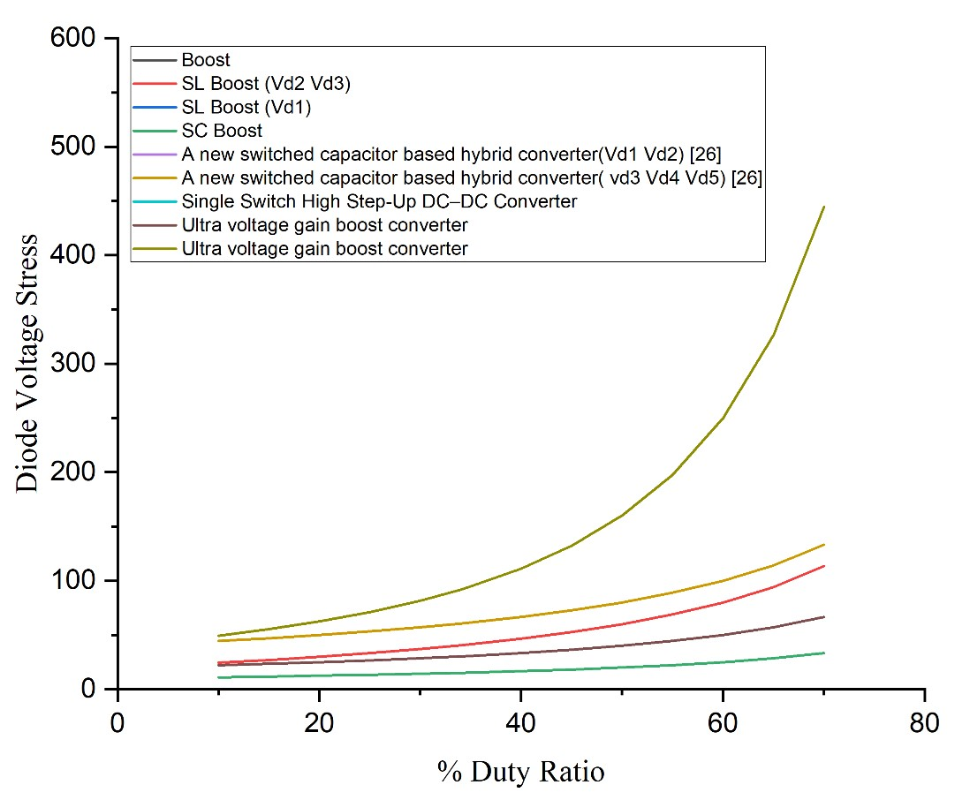

*Fig 4.16 Diode voltage stresses*

Fig 4.16 shows the diode voltage stresses of different converters. The diode voltage stress values of proposed converter with other topologies are compared. Fig 4.17 shows the diode voltage gain of different converters. The voltage gain of various converter topologies are presented in comparison with the proposed converter.

From the above we can clearly say that the voltage gain of the proposed converter is very large than the other DC-DC converter topologies. The voltage gain of various converter topologies are presented in comparison with the proposed converter. The main objective of the proposed converter is achieved using Boost converter which gains the voltage with lower voltage stresses and lower current stresses for different duty ratios which is used for Electric vehicle applications. Various converter topologies are presented in comparison with the proposed converter.

The proposed converter provides high voltage-gain while at the same time, imposing small voltage stresses on the active devices. Such features make the proposed converter to suitable well for electric vehicle applications. Gain of various converter topologies are presented in comparison with the proposed converter. The proposed converter is more efficient than other topologies.

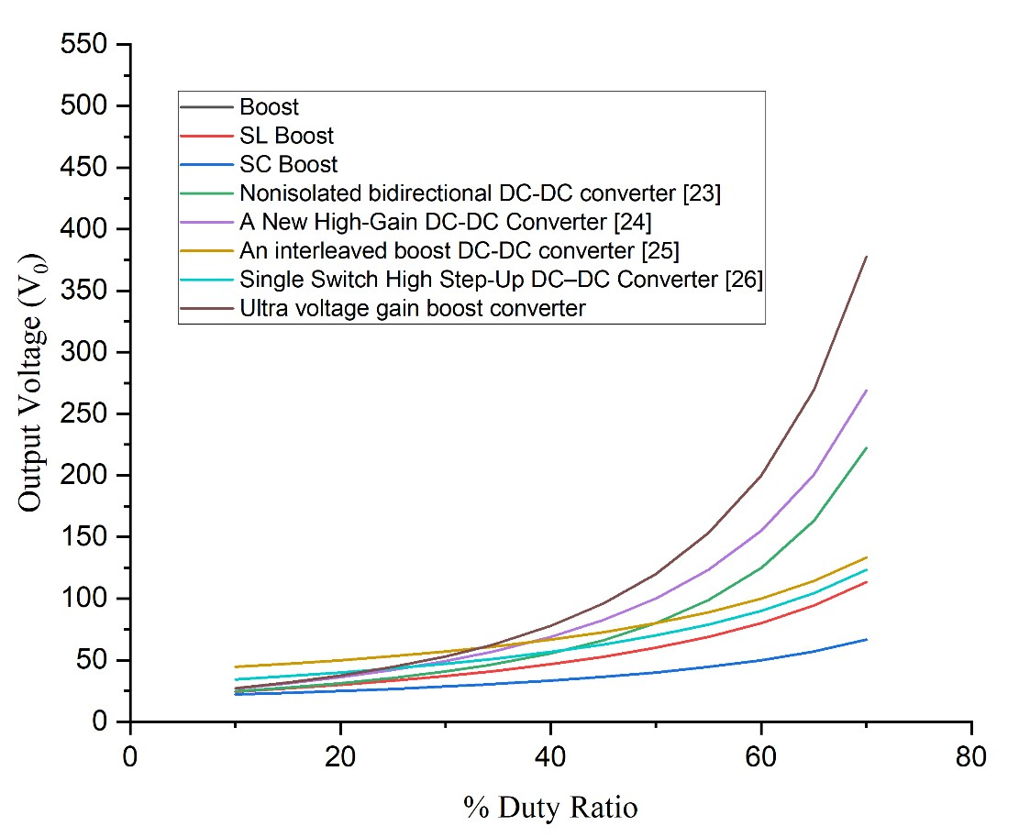

*Fig 4.17 Output voltage (Vo)*

Fig 4.18 shows the Voltage gain values of different converters. The Boosting factor of various converter topologies are presented in comparison with the proposed converter. "voltage gain" is regarding one of the main aspects regarding various types of Boost converters.

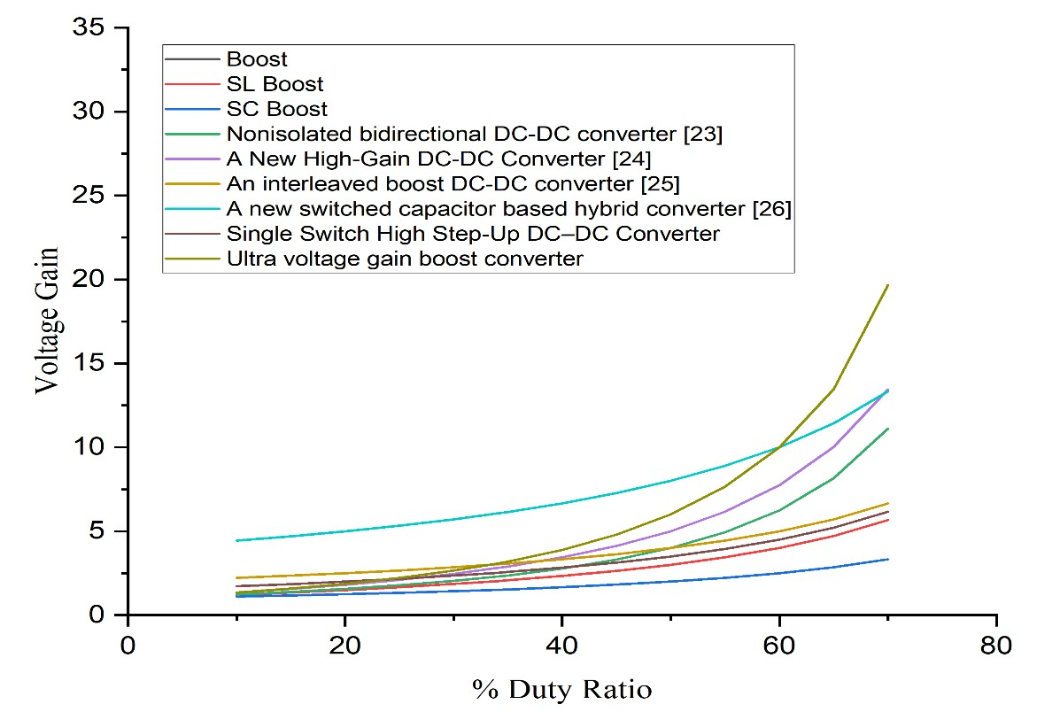

*Fig 4.18 Voltage Gain*

### 4.5 Summary

Here the proposed converter is simulated using the MATLAB software using the theoretically designed specifications. The input, output voltage and currents waveforms are clearly illustrated along with their values comparison. Similarly, to show that the converter experiencing lower switching stresses, lower voltage and current stresses of all the switches are also represented clearly. The proposed structures are more suitable for modern applications in which it is desirable to achieve high voltage gains by using non-extreme duty-cycles.

## CHAPTER 5 CONCLUSION AND FUTURE SCOPE

### 5.1 Conclusion

The purpose of this project was to develop a new dc/dc boost configuration with high voltage-gain capability for fuel cell converters. The developed configuration consisted of three switches, two diodes, and three inductors. A theoretical analysis of the converter demonstrated its high voltage-gain, low voltage and current stress on its devices, and high efficiency. The Simulation results obtained were consistent with the theoretical analysis of the converter.

### 5.2 Future scope

The proposed converter has the features like increasing step-up gain voltage, continuous input current, increasing efficiency and less number of components. Hence perfectly suitable for fuel cell system and Electric vehicle applications.

## REFERENCES

1. Zaid, M.; Lin, C.-H.; Khan, S.; Ahmad, J.; Tariq, M.; Mahmood, A.; Sarwar, A.;

Alamri, B.; Alahmadi, A. “ Family of transformerless quadratic boost high gain dc-dc converters”.Energies 2021, 14, 4372. [CrossRef]

1. Barbosa, E.A.O.; Carvalho, M.R.S.D.; Rodrigues Limongi, L.; Cavalcanti, M.C.; Barbosa, E.J.; Azevedo, G.M.D.S. “High-gain high-efficiency dc–dc converter with single-core parallel operation switched inductors and rectifier voltage multiplier cell”. Energies 2021, 14, 4634. [CrossRef]
2. Pereira, A.V.C.; Cavalcanti, M.C.; Azevedo, G.M.; Bradaschia, F.; Neto, R.C.; Carvalho, M.R.S.D."A novel single-switch high step-up dc–dc converter with threewinding coupled inductor”. Energies 2021, 14, 6288. [CrossRef]
3. Souza, L.C.; Morais, D.C.; Silva, L.D.S.D.C.E.; Seixas, F.J.M.D.; Arenas, L.D.O. “DC-DC 3SSC-a-based boost converter: Analysis, design, and experimental validation”. Energies 2021, 14, 6771. [CrossRef]
4. Gholizadeh, H.; Gorji, S.A.; Afjei, E.; Sera, “D. Design and implementation of a new cuk-based step-up DC–DC converter”. Energies 2021, 14, 6975. [CrossRef]
5. Chub, A.; Vinnikov, D.; Blaabjerg, F.; Peng, F.Z. “A review of galvanically isolated impedance-source DC-DC converters”. IEEE Trans. Power Electron. 2016, 31, 2808– 2828. [CrossRef]
6. Abdel-Rahim, O.; Chub, A.; Blinov, A.; Vinnikov, D. “New high-gain noninverting buck-boost converter”. In Proceedings of the IECON 2021–47th Annual Conference of the IEEE Industrial Electronics Society, Toronto, ON, Canada, 13 October 2021; pp. 1–6.

[8]. Ojeda-Rodríguez, Á.; González-Vizuete, P.; Bernal-Méndez, J.; Martín-Prats, M.A. “A survey on bidirectional dc/dc power converter topologies for the future hybrid and all electric aircrafts”. Energies 2020, 13, 4883. [CrossRef]

[9] De Souza, A.F.; Tofoli, F.L.; Ribeiro, E.R. Switched capacitor dc-dc converters: A survey on the main topologies, design characteristics, and applications. Energies 2021, 14, 2231. [CrossRef]

[10]. Forouzesh, M.; Siwakoti, Y.P.; Gorji, S.A.; Blaabjerg, F.; Lehman, B. Step-up DC-DC converters: A comprehensive review of voltage-boosting techniques, topologies, and applications. IEEE Trans. Power Electron. 2017, 32, 9143–9178.

[CrossRef]

[11]. Andrade, A.M.S.S.; Martins, M.L.D.S. “Quadratic-boost with stacked zeta converter for high voltage gain applications”. IEEE J. Emerg. Sel. Top. Power Electron. 2017, 5, 1787–1796. [CrossRef]

[12]. Ai, J.; Lin, M. “Ultra large gain step-up coupled-inductor dc-dc converter with an asymmetric voltage multiplier network for a sustainable energy system”. IEEE Trans. Power Electron. 2017, 32, 6896–6903. [CrossRef]

1. Zhang, Y.; Gao, Y.; Zhou, L.; Sumner, M. “A switched-capacitor bidirectional dcdc converter with wide voltage gain range for electric vehicles with hybrid energy sources”. IEEE Trans. Power Electron. 2018, 33, 9459–9469. [CrossRef]
2. Axelrod, B.; Berkovich, Y.; Ioinovici, A. Switched-capacitor/switched-inductor structures for getting transformerless hybrid DC–DC pwm converters. IEEE Trans. Circuits Syst. 2008, 55, 687–696. [CrossRef]

[15]. Young, C.-M.; Chen, M.-H.; Chang, T.-A.; Ko, C.-C.; Jen, K.-K. Cascade

Cockcroft–Walton Voltage Multiplier Applied to Transformerless High Step-Up DC–

DC Converter. IEEE Trans. Ind. Electron. 2013, 60, 523–537. [CrossRef]

[16]. Andrade, A.M.S.S.; Hey, H.L.; Schuch, L.; da Silva Martins, M.L. Comparative Evaluation of Single Switch High-Voltage Step-Up Topologies Based on Boost and Zeta PWM Cells. IEEE Trans. Ind. Electron. 2018, 65, 2322–2334. [CrossRef]

1. De Paula, W.J.; Júnior, D.D.O.; Pereira, D.D.; Tofoli, F.L. “Survey on non-isolated high-voltage step-up dc–dc topologies based on the boost converter”. IET Power Electron. 2015, 8, 2044–2057
2. Waradzyn, Z.; Stala, R.; Mondzik, A.; Penczek, A.; Skala, A.; Pirog, S. “Efficiency

Analysis of MOSFET-Based Air-Choke Resonant DC–DC Step-Up SwitchedCapacitor Voltage Multipliers”. IEEE Trans. Ind. Electron. 2017, 64, 8728–8738. [CrossRef]

[19]. Cervera, A.; Evzelman, M.; Peretz, M.M.; Ben-Yaakov, S. “A high-efficiency resonant switched capacitor converter with continuous conversion ratio”. IEEE Trans.

Power Electron. 2015, 30, 1373–1382. [CrossRef]

1. Stala, R.; Waradzyn, Z.; Mondzik, A.; Penczek, A.; Skała, “A. DC–DC high stepup converter with low count of switches based on resonant switched-capacitor topology”. In Proceedings of the 2019 21st European Conference on Power Electronics and Applications (EPE’19 ECCE Europe), Genova, Italy, 2–5 September 2019; pp. P.1–P.10.
2. Shoyama, M.; Naka, T.; Ninomiya, T. “Resonant switched capacitor converter with high efficiency”. In Proceedings of the 2004 IEEE 35th Annual Power Electronics Specialists Conference 2004, Aachen, Germany, 20–25 June 2004; Volume 5, pp. 3780–3786. [CrossRef]
3. Kesarwani, K.; Sangwan, R.; Stauth, J.T. “Resonant-switched capacitor converters for chip-scale power delivery: Design and implementation”. IEEE Trans. Power Electron. 2015, 30, 6966–6977. [CrossRef]
4. Ardi, H.; Ajami, A.; Kardan, F.; Avilagh, S.N. “Analysis and implementation of a nonisolated bidirectional DC-DC converter with high voltage gain”. IEEE Trans. Ind. Electron. 2016, 63, 4878–4888.
5. Ahmad, J.; Zaid, M.; Sarwar, A.; Lin, C.-H.; Asim, M.; Yadav, R.K.; Tariq, M.; Satpathi, K.; Alamri, B. “A New High-Gain DC-DC Converter with Continuous Input

Current for DC Microgrid Applications”. Energies 2021, 14, 2629. [CrossRef] [25] R. Gules, L. L. Pfitscher, and L. C. Franco, “An interleaved boost DC-DC converter with large conversion ratio,” in Proc. IEEE Int. Symp. Ind. Electron., 2003, pp. 411–416.

[26] Saravanan, S., & Babu, N. R. (2018). “Design and Development of Single Switch High Step-Up DC–DC Converter”. IEEE Journal of Emerging and Selected Topics in

Power Electronics, 6(2), 855–863. doi:10.1109/jestpe.2017.2739819